1. Name of the Certificate ¹
Field of study 3151 H knitter
2. Translated title of the Certificate ²
Učebný odbor 3151 H pletiar (en)
3. Profile of skills and competences
The holder of the certificate is able:
- to act independently in social and professional life,
- to express themselves in the official language and one foreign language in written and spoken form,
- to apply the basic principles of financial literacy, consumer protection and to understand business and work,
- to use information and communication technologies to solve practical tasks,
- to work in diverse groups, to cooperate in a team, to organise their work,
- to act environmentally with a view to a sustainable development strategy,
- to apply the principles of occupational health and safety and environmental protection,
- to choose suitable technological procedures and to implement the working procedure independently,
- to identify textile fibres,
- to draw up knitwear production process,
- to master basic types of weaves,
- to analyse the knitwear and determine its parameters,
- to inspect and assess the quality of completed products,
- to detect knitting errors and find a way to correct them,
- to eliminate errors in knitted fabrics caused by incorrect setting of the machine and unsuitable material used,
- to employ methods and techniques of industrial and craft production of textile materials,
- to operate basic braiding machines, sewing machines and devices in the conditioning room,
- to conduct standard maintenance on machinery, tools and equipment,
- to carry out any given operation in a quality manner within the set time limit,
- to work independently, to continuously assess the quality of performed operations,
- to verify the basic properties of textile fibres and materials in the usual way,
- to recommend a suitable technological process for making knitted products,
- to apply technical standards in practical activities in the production of individual products,
- to handle material and energy in a cost-effective way,
- to carry out professional activities in compliance with the principles of environmental protection.

4. Range of occupations accessible to the holder of the certificate ³
Graduates find work as qualified professionals in large, medium, and small companies in textile and clothing industries, specialised production, services, and in the field of medium or small businesses. Examples of potential job titles include: braiding machine operator (knitter).

5. Official basis of the certificate
Body awarding the certificate | Authority providing accreditation / recognition of the certificate
Ministry of Education, Science, Research and Sport of the Slovak Republic
Stromová 1
813 30 Bratislava
Phone: +421 2/59 374 111
www.minedu.sk
Level of the certificate (national or European) ¹  Secondary vocational education  SKQF/EQF 3  ISCED 353 | Grading scale / Pass requirements  1 – excellent  2 – praiseworthy  3 – good  4 – sufficient  5 – insufficient
Access to e next level of education / training 1  Advanced study educational programmes for graduates of the 3-year field of study  SKQF/EQF 4, ISCED 454 | International agreements on the recognition of qualifications ¹
Legal basis
Act No. 245/2008 Coll. on Education and Training (Education Act) and on amendment of certain acts; Act No. 61/2015 Coll. on Vocational Education and Training and on amendment of certain acts; Decree of the Ministry of Education of the Slovak Republic no. 318/2008 Coll. on the completion of studies at secondary schools, as amended.
6. Officially recognised ways of acquiring the certificate
Successful completion of the three-year training program in the given field of study by passing the final examination.
7. Additional information
This Europass Certificate Supplement is valid together with the school leaving certificate issued by the relevant secondary school (the name and address of the school is specified on the certificate). More details about the education and training system are available at www.minedu.sk/data/files/7421.jpg, more details as to the organisation of the educational system are available at www.minedu.sk, and the details of educational programs are available at www.siov.sk and at the website of the specified school.
Entry requirements ¹
- Completion of 9th year of primary school
- Demonstration of required knowledge prerequisites via admission procedure

More information (including a description of the national qualifications system)
Ministry of Education, Science, Research and Sport of the Slovak Republic, Study and Training Group
https://www.minedu.sk/18673-sk/studijne-a-ucebne-odbory-sauo/
National Europass Centre
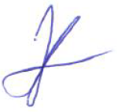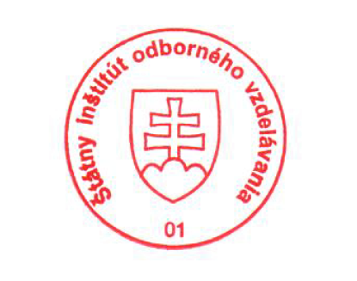State Vocational Education Institute
Bellova 54/a,
837 63 Bratislava
europass@siov.sk
www.europass.sk

