1. Name of the Certificate ¹
Field of study 3282 F footwear production
2. Translated title of the Certificate ²
Učebný odbor 3282 F výroba obuvi (sk)
3. Profile of skills and competences
The holder of the certificate is able:
- to collaborate on the resolution of simple problems and to work with others,
- to express themselves clearly in the official language,
- to describe their opportunities on the job market and their potential personal and career development paths,
- to use basic information and communication technologies,
- to act environmentally with a view to a sustainable development strategy,
- to apply the principles of occupational health and safety and environmental protection,
- to prepare the workplace,
- to choose suitable work tools, work aids, and personal protective equipment,
- to choose suitable materials and assess their properties with regard to selected working procedures,
- to perform simple professional activities in the uppers and soles assembly workshops, and to handle materials in accordance with the prescribed working procedures,
- to work independently according to the prescribed technological procedure,
- to choose the most effective work procedure for completing simple professional operations,
- to perform various professional operations – separation of different kinds of materials, glue coating, simple modifications of parts and components, sewing parts together, and preparatory and finishing operations in the production of footwear,
- to transport material and products using simple transport equipment,
- to get a single-purpose machine ready for work, to perform its simple setup and routine maintenance,
- to put away and properly store products, instruments, and tools,
- to work economically with materials and raw materials, with energy, with machines, and equipment as part of specific technological processes, to pack and adjust products,
- to observe technological discipline, standards, product quality parameters,
- to carry out professional activities in compliance with the principles of environmental protection.
4. Range of occupations accessible to the holder of the certificate ³
Graduates find work as workers with basic vocational training in the field of footwear and leather production, simple and auxiliary qualified work in large, medium, and small companies in the clothing industry, in specialised production, and in the field of medium or small operations.
Examples of potential job titles include: auxiliary worker in footwear and leather production (in footwear handling, in uppers assembly workshops, in soles assembly workshops).

5. Official basis of the certificate
Body awarding the certificate | Authority providing accreditation / recognition of the certificate
Ministry of Education, Science, Research and Sport of the Slovak Republic
Stromová 1
813 30 Bratislava
Phone: +421 2/59 374 111
www.minedu.sk
Level of the certificate (national or European) ¹  Lower secondary vocational education  SKQF/EQF 2  ISCED 253 | Grading scale / Pass requirements  1 – excellent  2 – praiseworthy  3 – good  4 – sufficient  5 – insufficient
Access to e next level of education / training 1  Permitted after successful completion of lower secondary education, ISCED 244. | International agreements on the recognition of qualifications ¹
Legal basis
Act No. 245/2008 Coll. on Education and Training (Education Act) and on amendment of certain acts; Act No. 61/2015 Coll. on Vocational Education and Training and on amendment of certain acts; Decree of the Ministry of Education of the Slovak Republic no. 318/2008 Coll. on the completion of studies at secondary schools, as amended.
6. Officially recognised ways of acquiring the certificate
Successful completion of the two-year training program in the given field of study by passing the final examination.
7. Additional information
This Europass Certificate Supplement is valid together with the school leaving certificate issued by the relevant secondary school (the name and address of the school is specified on the certificate). More details about the education and training system are available at www.minedu.sk/data/files/7421.jpg, more details as to the organisation of the educational system are available at www.minedu.sk, and the details of educational programs are available at www.siov.sk and at the website of the specified school.
Entry requirements ¹
- candidate who has not completed the primary school's curriculum in the last year or has not completed the last year successfully
More information (including a description of the national qualifications system)
Ministry of Education, Science, Research and Sport of the Slovak Republic, Study and Training Group
https://www.minedu.sk/18673-sk/studijne-a-ucebne-odbory-sauo/
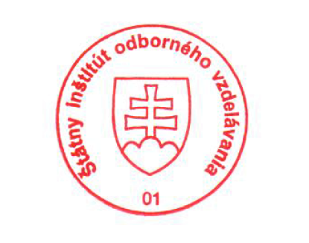 National Europass Centre
State Vocational Education Institute
Bellova 54/a,
837 63 Bratislava
europass@siov.sk
www.europass.sk

