1. Name of the Certificate ¹
Field of study 3178 F ready-to-wear clothing production
2. Translated title of the Certificate ²
Učebný odbor 3178 F výroba konfekcie (sk)
3. Profile of skills and competences
The holder of the certificate is able:
- to collaborate on the resolution of simple problems and to work with others,
- to express themselves clearly in the official language,
- to describe their opportunities on the job market and their potential personal and career development paths,
- to use basic information and communication technologies,
- to act environmentally with a view to a sustainable development strategy,
- to apply the principles of occupational health and safety and environmental protection,
- to prepare the workplace,
- to use simple professional terminology and use it at work,
- to sew basic hand stitches on products,
- to take body measurements,
- to draw a pattern from a professional magazine and make adjustments (shorten, lengthen, narrow, widen),
- to apply seams to a simple product and make the product by themselves,
- to carry out simple operations in the production of clothing, underwear and ready-to-wear technical clothing,
- to iron finished products and to properly carry out operations related to in-process ironing,
- to identify and fix product defects,
- to make simple clothes and linen adjustments,
- to operate basic machines during the joining, thermoforming, and finishing process,
- to carry out basic clothes maintenance and cleaning,
- to put away and properly store products, instruments, and tools,
- to adhere to the prescribed quality criteria,
- to perform work in the warehouse of material, minor preparation, and finished products,
- to handle material and energy in a cost-effective way,
- to carry out professional activities in compliance with the principles of environmental protection.
4. Range of occupations accessible to the holder of the certificate ³
Graduates find work as workers with basic vocational training performing simple machine and manual work in the production of clothing, underwear, and ready-to-wear technical clothing, in warehouses with basic and auxiliary materials, in warehouses with finished products used in large, medium, and small companies in the clothing industry, in specialised production, and in the field of medium or small operations.
Examples of potential job titles include: auxiliary worker in clothing production, seamstress of clothing and ready-to-wear technical clothing.

5. Official basis of the certificate
Body awarding the certificate | Authority providing accreditation / recognition of the certificate
Ministry of Education, Science, Research and Sport of the Slovak Republic
Stromová 1
813 30 Bratislava
Phone: +421 2/59 374 111
www.minedu.sk
Level of the certificate (national or European) ¹  Lower secondary vocational education  SKQF/EQF 2  ISCED 253 | Grading scale / Pass requirements  1 – excellent  2 – praiseworthy  3 – good  4 – sufficient  5 – insufficient
Access to e next level of education / training 1  Permitted after successful completion of lower secondary education, ISCED 244. | International agreements on the recognition of qualifications ¹
Legal basis
Act No. 245/2008 Coll. on Education and Training (Education Act) and on amendment of certain acts; Act No. 61/2015 Coll. on Vocational Education and Training and on amendment of certain acts; Decree of the Ministry of Education of the Slovak Republic no. 318/2008 Coll. on the completion of studies at secondary schools, as amended.
6. Officially recognised ways of acquiring the certificate
Successful completion of the two-year training program in the given field of study by passing the final examination.
7. Additional information
This Europass Certificate Supplement is valid together with the school leaving certificate issued by the relevant secondary school (the name and address of the school is specified on the certificate). More details about the education and training system are available at www.minedu.sk/data/files/7421.jpg, more details as to the organisation of the educational system are available at www.minedu.sk, and the details of educational programs are available at www.siov.sk and at the website of the specified school.
Entry requirements ¹
- candidate who has not completed the primary school's curriculum in the last year or has not completed the last year successfully
Further information (including information on the national qualifications system)
Ministry of Education, Science, Research and Sport of the Slovak Republic, Study and Training Group
https://www.minedu.sk/18673-sk/studijne-a-ucebne-odbory-sauo/
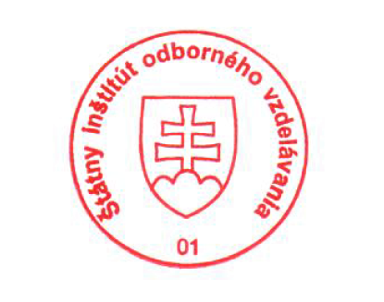 National Europass Centre
State Vocational Education Institute
Bellova 54/a,
837 63 Bratislava
europass@siov.sk
www.europass.sk

