1. Name of the Certificate ¹
Field of study 3179 F textile production
2. Translated title of the Certificate ²
Učebný odbor 3179 F textilná výroba (sk)
3. Profile of skills and competences
The holder of the certificate is able:
- to collaborate on the resolution of simple problems and to work with others,
- to express themselves clearly in the official language,
- to describe their opportunities on the job market and their potential personal and career development paths,
- to use basic information and communication technologies,
- to act environmentally with a view to a sustainable development strategy,
- to apply the principles of occupational health and safety and environmental protection,
- to prepare the workplace,
- to use simple professional terminology and use it at work,
- to choose suitable work tools, work aids, and personal protective equipment,
- to work independently according to the prescribed technological procedure,
- to handle material in all forms they work with,
- to transport material and products using simple transport equipment,
- to pack and adjust products,
- to operate and clean simple machines and equipment and perform mandatory maintenance,
- to put away and properly store products, instruments, and tools,
- to work economically with materials and raw materials, with energy, with machines, and equipment as part of specific technological processes,
- to employ methods and techniques of industrial and craft production of textile materials,
- to observe technological discipline, standards, product quality parameters,
- to fix product and weave errors,
- to handle material and energy in a cost-effective way,
- to carry out professional activities in compliance with the principles of environmental protection.
4. Range of occupations accessible to the holder of the certificate ³
Graduates find work as workers with basic vocational training in textile production in simple and auxiliary work according to a narrower specification of textile preparation in the field of refining, spinning, weaving or knitting, in warehouses with basic and auxiliary materials, in warehouses with finished products, and in large, medium and small companies in the textile industry and in the field of medium or small operations.
Examples of potential job titles include auxiliary worker in textile production.

5. Official basis of the certificate
Body awarding the certificate | Authority providing accreditation / recognition of the certificate
Ministry of Education, Science, Research and Sport of the Slovak Republic
Stromová 1
813 30 Bratislava
Phone: +421 2/59 374 111
www.minedu.sk
Level of the certificate (national or European) ¹  Lower secondary vocational education  SKQF/EQF 2  ISCED 253 | Grading scale / Pass requirements  1 – excellent  2 – praiseworthy  3 – good  4 – sufficient  5 – insufficient
Access to e next level of education / training 1  Permitted after successful completion of lower secondary education, ISCED 244. | International agreements on the recognition of qualifications ¹
Legal basis
Act No. 245/2008 Coll. on Education and Training (Education Act) and on amendment of certain acts; Act No. 61/2015 Coll. on Vocational Education and Training and on amendment of certain acts; Decree of the Ministry of Education of the Slovak Republic no. 318/2008 Coll. on the completion of studies at secondary schools, as amended.
6. Officially recognised ways of acquiring the certificate
Successful completion of the two-year training program in the given field of study by passing the final examination.
7. Additional information
This Europass Certificate Supplement is valid together with the school leaving certificate issued by the relevant secondary school (the name and address of the school is specified on the certificate). More details about the education and training system are available at www.minedu.sk/data/files/7421.jpg, more details as to the organisation of the educational system are available at www.minedu.sk, and the details of educational programs are available at www.siov.sk and at the website of the specified school.
Entry requirements ¹
- candidate who has not completed the primary school's curriculum in the last year or has not completed the last year successfully
More information (including a description of the national qualifications system)
Ministry of Education, Science, Research and Sport of the Slovak Republic, Study and Training Group
https://www.minedu.sk/18673-sk/studijne-a-ucebne-odbory-sauo/
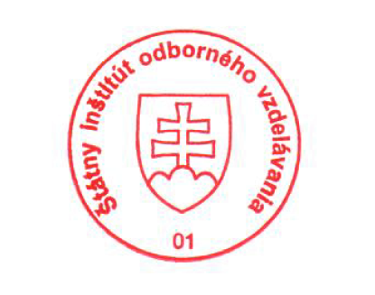 National Europass Centre
State Vocational Education Institute
Bellova 54/a,
837 63 Bratislava
europass@siov.sk
www.europass.sk

