1. Name of the Certificate ¹
Field of study 2414 L 01 engineering – manufacture, assembly and repair of devices
2. Translated title of the Certificate ²
Študijný odbor 2414 L 01 strojárstvo-výroba, montáž a oprava prístrojov (sk)
3. Profile of skills and competences
The holder of the certificate is able:
- to communicate correctly in the official language, both verbally and in writing,
- to communicate using one world language at the B1 level per the Common European Reference Framework,
- to adapt to changing living and working conditions, to work in a team and to take responsibility for tasks,
- to work with information, to use information and communication technologies and equipment,
- to apply basic mathematical relations and the laws of physics and chemistry when resolving practical tasks,
- to apply the principles of financial literacy, consumer protection and to understand business and the work,
- to act environmentally with a view to a sustainable development strategy,
- to apply the principles of occupational health and safety and environmental protection,
- to read technical drawings, diagrams, work instructions, catalogues and technical documentation, standards, and professional literature,
- to create images of machine parts and assemblies using CAD/CAM systems,
- to be familiar with the operation of machinery used in engineering,
- to solve technical calculations using professional technical literature and standards for the design of machine parts,
- to explain the basic technological procedures for manual processing of materials,
- to explain the procedures for assembling and disassembling machinery, equipment, and their units,
- to describe the procedures for using equipment, tools, and agents,
- to explain the operation of transmissions used in mechanisms and machines as well as the basic calculations of their parameters,
- to describe the principles of regulating and control engineering and automatic management systems,
- to describe procedures for measuring electrical and non-electrical parameters,
- to explain the possibilities of introducing mechanisation and automation,
- to create records of operation, maintenance and repair of machinery and equipment,
- to carry out basic tasks in manual and machine working of metal,
- to use engineering standards, technical literature, and fitting system and apply them at work,
- to use appropriate tools, instruments, agents, and work aids,
- to choose optimal working conditions, to comply with technical rules,
- to implement procedures for processing and treatment of materials using appropriate tools, aids, and agents.
4. Range of occupations accessible to the holder of the certificate ³
Graduates are qualified workers able to independently carry out activities in repairing, assembling, adjusting, reviving, testing, and checking a wide range of instruments, machines and equipment, as well as to perform work of technical, structural, technological, assembly and operational nature; they may also be employed in other positions at specialised departments or as specialists carrying out complex skilled work in accordance with their occupational background. Examples of possible job positions: operator, dispatcher, technician, foreman, quality controller in the field of machine engineering.

5. Official basis of the certificate
Body awarding the certificate | Authority providing accreditation / recognition of the certificate
Ministry of Education, Science, Research and Sport of the Slovak Republic
Stromová 1
813 30 Bratislava
Phone: +421 2/59 374 111
www.minedu.sk
Level of the certificate (national or European) ¹  Full secondary vocational education  SKQF/EQF 4  ISCED 454 | Grading scale / Pass requirements  1 – excellent  2 – praiseworthy  3 – good  4 – sufficient  5 – insufficient
Access to e next level of education / training 1  Higher vocational education SKQF/EQF 5, ISCED 554  University, 1st degree, ISCED 655, 645, 665 | International agreements on the recognition of qualifications ¹
Legal basis
Act No. 245/2008 Coll. on Education and Training (Education Act) and on amendment of certain acts; Act No. 61/2015 Coll. on Vocational Education and Training and on amendment of certain acts; Decree of the Ministry of Education of the Slovak Republic no. 318/2008 Coll. on the completion of studies at secondary schools, as amended.
6. Officially recognised ways of acquiring the certificate
Successful completion of the four-year training program in the given field of study by passing the final examination.
7. Additional information
This Europass Certificate Supplement is valid together with the school leaving certificate issued by the relevant secondary school (the name and address of the school is specified on the certificate). More details about the education and training system are available at www.minedu.sk/data/files/7421.jpg, more details as to the organisation of the educational system are available at www.minedu.sk, and the details of educational programs are available at www.siov.sk and at the website of the specified school.
Entry requirements ¹
- secondary vocational education in the given field of study, ISCED 353
- fulfilment of prerequisites in the admission procedure

More information (including a description of the national qualifications system)
Ministry of Education, Science, Research and Sport of the Slovak Republic, Study and Training Group
https://www.minedu.sk/18673-sk/studijne-a-ucebne-odbory-sauo/
National Europass Centre
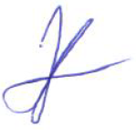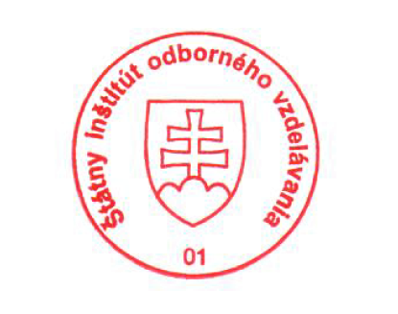State Vocational Education Institute
Bellova 54/a,
837 63 Bratislava
europass@siov.sk
www.europass.sk

