1. Name of the Certificate ¹
Field of study 2387 M mechatronics
2. Translated title of the Certificate ²
Študijný odbor 2387 M mechatronika (sk)
3. Profile of skills and competences
The holder of the certificate is able:
- to communicate correctly in the official language, both verbally and in writing,
- to communicate using one world language at the B1 level per the Common European Reference Framework,
- to adapt to changing living and working conditions, to work in a team and to take responsibility for tasks,
- to work with information, to use information and communication technologies and equipment,
- to apply the principles of financial literacy, consumer protection and to understand business and the work,
- to act environmentally with a view to a sustainable development strategy,
- to apply the principles of occupational health and safety and environmental protection,
- to read and draw technical drawings of engineering and electro-technical nature, fluid mechanism diagrams, and electric and electronic circuits using technical standardisation principles,
- to design suitable material for the mechatronic system elements,
- to dimension machine components and assemble them into simple functional units,
- to carry out the measurement of a physical/technical parameter according to the instructions and assess its condition on the basis of the measurement results,
- to build a circuit for measurement on the sensor and verify its properties,
- to write a simple programme for controlling a logic circuit, a microcontroller, a robot, or a PLC system,
- to explain the operation principle and the possibilities of using regulation elements,
- to develop a procedure for the production of components and their assembly into a functional unit,
- to construct simple mechanical nodes,
- to develop and edit control programme for NC machines and robots,
- to implement the programme into the control unit and to carry out the operation of NC machines and robots,
- to develop and verify the operation of a simple electronic circuit,
- to remove electronic circuit failures,
- to develop and edit application programmes for microcontrollers, logic circuits and to eliminate their potential defects,
- to assemble and disassemble simple units,
- to implement and modify fluid mechanism operation,
- to programme and diagnose the operation of PLC-controlled devices,
- to manage and regulate the operation of the mechatronic system,
- to apply the rules and principles of occupational safety and health protection.
4. Range of occupations accessible to the holder of the certificate ³
Graduates find work as mechatronics, they perform work operations in the field of inspection, diagnosis, adjustment and repair of electrical circuits, electric drives, pneumatic and hydraulic drives, control electronics and regulation engineering of an automated production line.

5. Official basis of the certificate
Body awarding the certificate | Authority providing accreditation / recognition of the certificate
Ministry of Education, Science, Research and Sport of the Slovak Republic
Stromová 1
813 30 Bratislava
Phone: +421 2/59 374 111
www.minedu.sk

Level of the certificate (national or European) ¹  Full secondary vocational education  SKQF/EQF 4  ISCED 354 | Grading scale / Pass requirements  1 – excellent  2 – praiseworthy  3 – good  4 – sufficient  5 – insufficient
Access to e next level of education / training 1  Higher vocational education SKQF/EQF 5, ISCED 554  University, 1st degree, ISCED 655, 645, 665 | International agreements on the recognition of qualifications ¹
Legal basis
Act No. 245/2008 Coll. on Education and Training (Education Act) and on amendment of certain acts; Act No. 61/2015 Coll. on Vocational Education and Training and on amendment of certain acts; Decree of the Ministry of Education of the Slovak Republic no. 318/2008 Coll. on the completion of studies at secondary schools, as amended.
6. Officially recognised ways of acquiring the certificate
Successful completion of the four-year training program in the given field of study by passing the final examination.
7. Additional information
This Europass Certificate Supplement is valid together with the school leaving certificate issued by the relevant secondary school (the name and address of the school is specified on the certificate). More details about the education and training system are available at www.minedu.sk/data/files/7421.jpg, more details as to the organisation of the educational system are available at www.minedu.sk, and the details of educational programs are available at www.siov.sk and at the website of the specified school.
Entry requirements ¹
- lower secondary education, ISCED 244
- fulfilment of prerequisites in the admission procedure

More information (including a description of the national qualifications system)
Ministry of Education, Science, Research and Sport of the Slovak Republic, Study and Training Group
https://www.minedu.sk/18673-sk/studijne-a-ucebne-odbory-sauo/

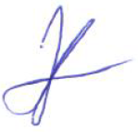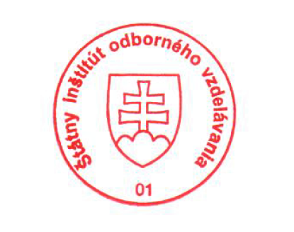 National Europass Centre
State Vocational Education Institute
Bellova 54/a,
837 63 Bratislava
europass@siov.sk
www.europass.sk

