1. Name of the Certificate ¹
Field of study 2262 K metallurgist – operator
2. Translated title of the Certificate ²
Študijný odbor 2262 K hutník- operátor (sk)
3. Profile of skills and competences
The holder of the certificate is able:
- to communicate correctly in the official language, both verbally and in writing,
- to communicate using one world language at least at the B1 level per the Common European Reference Framework,
- to adapt to changing living and working conditions, to work in a team and to take responsibility for tasks,
- to work with information, to use information and communication technologies and equipment,
- to apply the principles of financial literacy, consumer protection and to understand business and the work,
- to act environmentally with a view to a sustainable development strategy,
- to apply the principles of occupational health and safety and environmental protection,
- to apply basic professional terminology in the field of metallurgy, foundry industry and other metalworking production, to be able to use general knowledge, concepts, terms, and principles to solve practical tasks,
- to apply knowledge of mathematics, physics and chemistry to solve problems of the applied theory of metallurgical and foundry production and to specify such solutions,
- to describe and explain the function of basic machine components, aggregates and mechanisms used in mechanical engineering and the foundry industry,
- to list the basic types of materials and semi-finished products used in metallurgical and foundry production, their technological properties, and methods of their processing,
- to explain the basic technological procedures of manual and machine processing, machining, heat treatment, casting, forming, forging, and welding,
- to explain the basic technological procedures of metal casting,
- to explain basic chemical analyses and determine the chemical composition of alloys,
- to explain basic metallurgical and foundry technologies,
- to follow approved procedures and technological rules, technical and technological standards,
- to work and choose appropriate tools, instruments, agents, and work aids,
- to make a simple product by casting into a mould with prior preparation of the moulding mixture and production of the model,
- to perform inter-operational and final checks of products using diagnostic methods and modern diagnostic devices and to evaluate their quality,
- to identify weaknesses in the technological procedure based on material defects.

4. Range of occupations accessible to the holder of the certificate ³
Graduates find work as metallurgists – operators operating single-purpose and special machinery during the metallurgical process, which are used to operate individual technological equipment during the production of metallic materials and alloys; they monitor and coordinate technological machinery and equipment, perform control and management activities on individual technological parts and carry out routine maintenance on operated equipment.

5. Official basis of the certificate
Body awarding the certificate | Authority providing accreditation / recognition of the certificate
Ministry of Education, Science, Research and Sport of the Slovak Republic
Stromová 1
813 30 Bratislava
Phone: +421 2/59 374 111
www.minedu.sk
Level of the certificate (national or European) ¹  Full secondary vocational education  SKQF/EQF 4  ISCED 354 | Grading scale / Pass requirements  1 – excellent  2 – praiseworthy  3 – good  4 – sufficient  5 – insufficient
Access to e next level of education / training 1  Higher vocational education SKQF/EQF 5, ISCED 554  University, 1st degree, ISCED 655, 645, 665 | International agreements on the recognition of qualifications ¹
Legal basis
Act No. 245/2008 Coll. on Education and Training (Education Act) and on amendment of certain acts; Act No. 61/2015 Coll. on Vocational Education and Training and on amendment of certain acts; Decree of the Ministry of Education of the Slovak Republic no. 318/2008 Coll. on the completion of studies at secondary schools, as amended.
6. Officially recognised ways of acquiring the certificate
Successful completion of the four-year training program in the given field of study by passing the final examination.
7. Additional information
This Europass Certificate Supplement is valid together with the school leaving certificate issued by the relevant secondary school (the name and address of the school is specified on the certificate). More details about the education and training system are available at www.minedu.sk/data/files/7421.jpg, more details as to the organisation of the educational system are available at www.minedu.sk, and the details of educational programs are available at www.siov.sk and at the website of the specified school.
Entry requirements ¹
- lower secondary education, ISCED 244
- fulfilment of prerequisites in the admission procedure

More information (including a description of the national qualifications system)
Ministry of Education, Science, Research and Sport of the Slovak Republic, Study and Training Group
https://www.minedu.sk/18673-sk/studijne-a-ucebne-odbory-sauo/

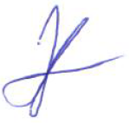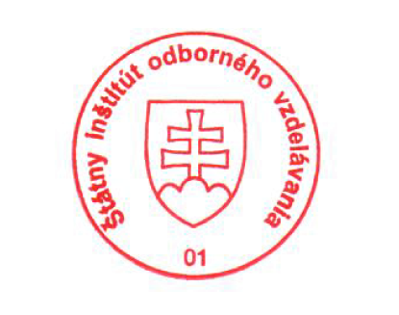 National Europass Centre
State Vocational Education Institute
Bellova 54/a,
837 63 Bratislava
europass@siov.sk
www.europass.sk

