1. Name of the Certificate ¹
Field of study 3756 L postal service
2. Translated title of the Certificate ²
Študijný odbor 3756 L poštová prevádzka (sk)
3. Profile of skills and competences
The holder of the certificate is able:
- to communicate correctly in the official language, both verbally and in writing,
- to communicate using one world language at least at the B1 level per the Common European Reference Framework,
- to adapt to changing living and working conditions, to work in a team and to take responsibility for assigned tasks,
- to work with information, to use information and communication technologies and equipment,
- to apply basic mathematical relations and the laws of physics when resolving practical tasks,
- to apply the principles of financial literacy, consumer protection and to understand business and the world of work,
- to act environmentally with a view to a sustainable development strategy,
- to apply the principles of occupational health and safety and environmental protection,
- to understand and locate information in generally binding legislation and operating regulations, and to present the required information to others,
- to collect, analyse and use technical operational and economic information for addressing day-to-day tasks related to the activity of a company engaged in postal service activities,
- to implement technological practices in the field of mail processing, monetary service, and other postal services,
- to draw up and maintain operating documents,
- to determine the appropriate selection and integration of simple machinery into the technological process employed in the field of postal services,
- to master the issue of the economic geography of the individual countries.

4. Range of occupations accessible to the holder of the certificate ³
Graduates find work as qualified professionals able to independently carry out skilled work in the field of postal services. They also find work as post office counter clerks, cash register clerks, cashiers, post office managers, and post office coordinators.

5. Official basis of the certificate
Body awarding the certificate | Authority providing accreditation / recognition of the certificate
Ministry of Education, Science, Research and Sport of the Slovak Republic
Stromová 1
813 30 Bratislava
Phone: +421 2/59 374 111
www.minedu.sk
Level of the certificate (national or European) ¹  Full secondary vocational education  SKQF/EQF 4  ISCED 454 | Grading scale / Pass requirements  1 – excellent  2 – praiseworthy  3 – good  4 – sufficient  5 – insufficient
Access to e next level of education / training 1  Higher vocational education SKQF/EQF 5, ISCED 554  University, 1st degree, ISCED 655, 645, 665 | International agreements on the recognition of qualifications ¹
Legal basis
Act No. 245/2008 Coll. on Education and Training (Education Act) and on amendment of certain acts; Act No. 61/2015 Coll. on Vocational Education and Training and on amendment of certain acts; Decree of the Ministry of Education of the Slovak Republic no. 318/2008 Coll. on the completion of studies at secondary schools, as amended.
6. Officially recognised ways of acquiring the certificate
Successful completion of the two-year training program in the given field of study by passing the final examination.
7. Additional information
This Europass Certificate Supplement is valid together with the school leaving certificate issued by the relevant secondary school (the name and address of the school is specified on the certificate). More details about the education and training system are available at www.minedu.sk/data/files/7421.jpg, more details as to the organisation of the educational system are available at www.minedu.sk, and the details of educational programs are available at www.siov.sk and at the website of the specified school.
Entry requirements ¹
- secondary vocational education in the given field of study, ISCED 353
- fulfilment of prerequisites in the admission procedure
More information (including a description of the national qualifications system)
Ministry of Education, Science, Research and Sport of the Slovak Republic, Study and Training Group
https://www.minedu.sk/18673-sk/studijne-a-ucebne-odbory-sauo/
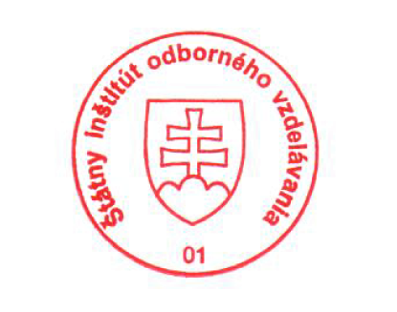 National Europass Centre
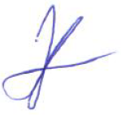State Vocational Education Institute
Bellova 54/a,
837 63 Bratislava
europass@siov.sk
www.europass.sk

