1. Name of the Certificate ¹
Field of study 3778 K information and communications technology technician
2. Translated title of the Certificate ²
Študijný odbor 3778 K technik informačných a telekomunikačných technológií (sk)
3. Profile of skills and competences
The holder of the certificate is able:
- to communicate correctly in the official language, both verbally and in writing,
- to communicate using one world language at the B1 level per the Common European Reference Framework,
- to adapt to changing living and working conditions, to work in a team and to take responsibility for tasks,
- to work with information, to use information and communication technologies and equipment,
- to apply basic mathematical relations and the laws of physics when resolving practical tasks,
- to apply the principles of financial literacy, consumer protection and to understand business and the work,
- to act environmentally with a view to a sustainable development strategy,
- to apply the principles of occupational health and safety and environmental protection,
- to define basic terms and to use professional terminology in the field of information and communications technologies,
- to understand and use standards, regulations, and technological procedures in the field of information and communications technologies,
- to express oneself using technical terminology and to understand technical documentation and literature,
- to define the basic principles and design of terminal connection and transmission systems, circuit logic solutions, and basic measurement methods in telecommunications and electronic communications,
- to explain the operating principles of digital exchanges and signalling types,
- to explain the basic principles of portable systems and telecommunications terminal equipment,
- to diagnose the operability and functionality of systems using metering techniques,
- to operate, install, and maintain telecommunications terminal equipment,
- to carry out the construction of local and trunk cables and the installation of basic connectors,
- to carry out the installation and repair of metallic, coaxial and optical cables, optical couplers, and independent optical fibre fusion.
4. Range of occupations accessible to the holder of the certificate ³
Graduates are qualified workers able to independently carry out technical work in operating, constructing, diagnosing, manufacturing, installing, and maintaining telecommunications equipment. They also find work as chief masters, electrical mechanics specialising in electric and electronic equipment, operators, professional technical personnel, and technicians.

5. Official basis of the certificate
Body awarding the certificate | Authority providing accreditation / recognition of the certificate
Ministry of Education, Science, Research and Sport of the Slovak Republic
Stromová 1
813 30 Bratislava
Phone: +421 2/59 374 111
www.minedu.sk
Level of the certificate (national or European) ¹  Full secondary vocational education  SKQF/EQF 4  ISCED 354 | Grading scale / Pass requirements  1 – excellent  2 – praiseworthy  3 – good  4 – sufficient  5 – insufficient
Access to e next level of education / training 1  Higher vocational education SKQF/EQF 5, ISCED 554  University, 1st degree, ISCED 655, 645, 665 | International agreements on the recognition of qualifications ¹
Legal basis
Act No. 245/2008 Coll. on Education and Training (Education Act) and on amendment of certain acts; Act No. 61/2015 Coll. on Vocational Education and Training and on amendment of certain acts; Decree of the Ministry of Education of the Slovak Republic no. 318/2008 Coll. on the completion of studies at secondary schools, as amended.
6. Officially recognised ways of acquiring the certificate
Successful completion of the four-year training program in the given field of study by passing the final examination.
7. Additional information
This Europass Certificate Supplement is valid together with the school leaving certificate issued by the relevant secondary school (the name and address of the school is specified on the certificate). More details about the education and training system are available at www.minedu.sk/data/files/7421.jpg, more details as to the organisation of the educational system are available at www.minedu.sk, and the details of educational programs are available at www.siov.sk and at the website of the specified school.
Entry requirements ¹
- lower secondary education, ISCED 244
- fulfilment of prerequisites in the admission procedure
More information (including a description of the national qualifications system)
Ministry of Education, Science, Research and Sport of the Slovak Republic, Study and Training Group
https://www.minedu.sk/18673-sk/studijne-a-ucebne-odbory-sauo/
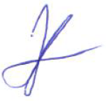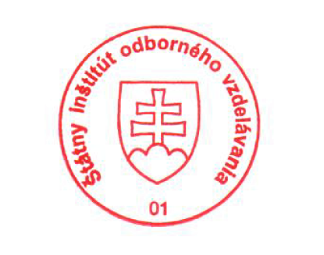 National Europass Centre
State Vocational Education Institute
Bellova 54/a,
837 63 Bratislava
europass@siov.sk
www.europass.sk

