1. Name of the Certificate ¹
Field of study 2841 M technology for the protection and creation of the environment
2. Translated title of the Certificate ²
Študijný odbor 2841 M technológia ochrany a tvorby životného prostredia (sk)
3. Profile of skills and competences
The holder of the certificate is able:
- carry out a survey of a selected area,
- carry out the collection, treatment and analysis of samples from the environmental components,
- carry out monitoring of the determined characteristics of the environmental components,
- analyse samples by physical, chemical and microbiological methods,
- evaluate the obtained data, process analyses,
- assess the condition of environmental components by biological and chemical methods,
- design and implement solutions in the field of treatment and purification of water, air and soil,
- propose solutions for waste disposal and recovery,
- get to terms with legislative regulations concerning the environment and to monitor their observance in practice,
- carry out a survey of environmental burdens, prepare a risk analysis of environmental burdens,
- apply the principles of ecological disposal of pollutants,
- carry out the rehabilitation of environmental burdens,
- apply technologies for the treatment and purification of water, air and soil,
- recultivate the environment by using modern methods of creating the environment according to the principles of sustainable development,
- observe the principles of safety at work and occupational hygiene,
- apply the principles of environmental protection.

4. Range of occupations accessible to the holder of the certificate ³
The graduate can be employed in professions in the environmental sector as a laboratory technician, controller, operations technician, technical and economic worker in environmental protection and creation and related services and of course in research fields.
Examples of possible job positions: water resources protection technician, drinking and waste water laboratory technician, sampler for drinking and waste water, waste management dispatcher, operation technician for sewage systems and waste water treatment plants.

5. Official basis of the certificate
Body awarding the certificate | Authority providing accreditation / recognition of the certificate
Ministry of Education, Science, Research and Sport of the Slovak Republic
Stromová 1
813 30 Bratislava
Phone: +421 2/59 374 111
www.minedu.sk
Level of the certificate (national or European) ¹  Full secondary vocational education  SKKR/EKR 4  ISCED 354 | Grading scale / Pass requirements  1 – excellent  2 – praiseworthy  3 – good  4 – sufficient  5 – insufficient
Access to e next level of education / training 1  University, 1st degree, ISCED 655, 645, 665  University, 2nd degree, ISCED 766, 767 | International agreements on the recognition of qualifications ¹
Legal basis
Act No. 245/2008 Coll. on Education and Training (Education Act) and on amendment of certain acts; Act No. 61/2015 Coll. on Vocational Education and Training and on amendment of certain acts; Decree of the Ministry of Education of the Slovak Republic no. 318/2008 Coll. on the completion of studies at secondary schools, as amended.
6. Officially recognised ways of acquiring the certificate
Successful completion of the four-year training program in the given field of study by passing the final examination.
7. Additional information
This Europass Certificate Supplement is valid together with the school leaving certificate issued by the relevant secondary school (the name and address of the school is specified on the certificate). More details about the education and training system are available at www.minedu.sk/data/files/7421.jpg, more details as to the organisation of the educational system are available at www.minedu.sk, and the details of educational programs are available at www.siov.sk and at the website of the specified school.
Entry requirements ¹
- lower secondary education, ISCED 244
- fulfilment of prerequisites in the admission procedure
More information (including a description of the national qualifications system)
Ministry of Education, Science, Research and Sport of the Slovak Republic, Study and Training Group
https://www.minedu.sk/18673-sk/studijne-a-ucebne-odbory-sauo/
National Europass Centre
State Vocational Education Institute
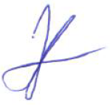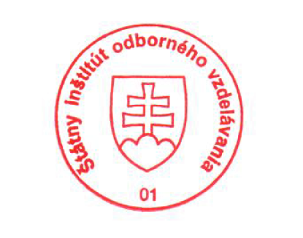Bellova 54/a,
837 63 Bratislava
europass@siov.sk
www.europass.sk

