1. Name of the Certificate ¹
Field of study 2949 M nutrition, health protection and food evaluation
2. Translated title of the Certificate ²
Študijný odbor 2949 M výživa, ochrana zdravia a hodnotenie potravín (sk)
3. Profile of skills and competences
The holder of the certificate is able:
- to communicate correctly in the official language, both verbally and in writing,
- to communicate using one world language at least at the B1 level per the Common European Reference Framework,
- to adapt to changing living and working conditions, to work in a team and to take responsibility for assigned tasks,
- to work with information, to use information and communication technologies and equipment,
- to apply mathematical relations and the laws and physics and chemistry when resolving practical tasks,
- to apply the principles of financial literacy, consumer protection and to understand business and the world of work,
- to act environmentally with a view to a sustainable development strategy,
- to apply the principles of occupational health and safety and environmental protection,
- to apply knowledge of analytical chemistry, biochemistry, microbiology,
- to define raw materials, additives and processing aids in food production,
- to master the principles of technological processes,
- to evaluate the course of production processes, technological processes and production economics,
- to master technological calculations,
- to explain the functions of the most important instruments, machines and devices in food processing industry,
- to explain the construction of machines and devices used in the production according to the specific sector and their function,
- to characterize technical and technological documentation and be able to use it,
- to use measuring and regulation technology in controlling technological processes,
- to use relevant standards, company regulations, labour regulations health and safety regulations,
- to assess food safety, create and control conditions for the production of safe food,
- to draw up nutrition and hygiene programs for public catering facilities, school canteens,
- to control nutrition and hygiene programs,
- to apply the principles of occupational hygiene, health and safety principles, ecological aspects of individual productions according to their orientation, to adhere to HACCP regulations.

4. Range of occupations accessible to the holder of the certificate ³
Graduates find work as qualified professionals in food production and related services or in establishments and laboratories as: foremen, laboratory technicians, technical and economic workers in food industry and in distribution and sale of food.

5. Official basis of the certificate
Body awarding the certificate | Authority providing accreditation / recognition of the certificate
Ministry of Education, Science, Research and Sport of the Slovak Republic
Stromová 1
813 30 Bratislava
Phone: +421 2/59 374 111
www.minedu.sk
Level of the certificate (national or European) ¹  Full secondary vocational education  SKQF/EQF 4  ISCED 354 | Grading scale / Pass requirements  1 – excellent  2 – praiseworthy  3 – good  4 – sufficient  5 – insufficient
Access to next level of education / training 1  Higher vocational education SKQF/EQF 5, ISCED 554  University, 1st degree, SKQF/EQF 6, ISCED 655, 645, 665  University, 2nd degree – continuous programs SKQF/EQF 7, ISCED 766 | International agreements on the recognition of qualifications ¹
Legal basis
Act No. 245/2008 Coll. on Education and Training (Education Act) and on amendment of certain acts; Act No. 61/2015 Coll. on Vocational Education and Training and on amendment of certain acts; Decree of the Ministry of Education of the Slovak Republic no. 318/2008 Coll. on the completion of studies at secondary schools, as amended.
6. Officially recognised ways of acquiring the certificate
Successful completion of the four-year training program in the given field of study by passing the final examination.
7. Additional information
This Europass Certificate Supplement is valid together with the school leaving certificate issued by the relevant secondary school (the name and address of the school is specified on the certificate). More details about the education and training system are available at www.minedu.sk/data/files/7421.jpg, more details as to the organisation of the educational system are available at www.minedu.sk, and the details of educational programs are available at www.siov.sk and at the website of the specified school.
Entry requirements ¹
- lower secondary education, ISCED 244
- fulfilment of prerequisites in the admission procedure
Further information (including information on the national qualifications system)
Ministry of Education, Science, Research and Sport of the Slovak Republic, Study and Training Group
https://www.minedu.sk/18673-sk/studijne-a-ucebne-odbory-sauo/
National Europass centre
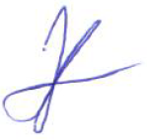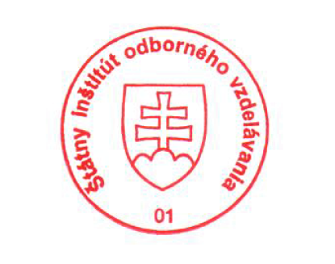State Vocational Education Institute
Bellova 54/a,
837 63 Bratislava
europass@siov.sk
www.europass.sk

