1. Name of the Certificate ¹
Field of study 2982 F food production
2. Translated title of the Certificate ²
Učebný odbor 2982 F potravinárska výroba (sk)
3. Profile of skills and competences
The holder of the certificate is able:
- to collaborate on the resolution of simple problems and to work with others,
- to express themselves clearly in the official language,
- to describe their opportunities on the job market and their potential personal and career development paths,
- to use basic information and communication technologies,
- to act environmentally with a view to a sustainable development strategy,
- to prepare the workplace,
- to work with raw materials and materials,
- to select the right working procedures,
- to use appropriate instruments, tools, machines and devices,
- to implement simple works in production, dispatching and services,
- to perform simple sanitation of relevant machines and devices,
- to properly store and place products, instruments and tools,
- to conduct sanitation measures at the workplace,
- to observe the principles of occupational hygiene, health and safety, fire protection and HACCP regulations in the relevant plants.

4. Range of occupations accessible to the holder of the certificate ³
Graduates find work as food production professionals and in the respective services in simple and auxiliary works. Examples of possible job positions: auxiliary worker in food processing industry, gastronomy, trade and services involving food commodities.

5. Official basis of the certificate
Body awarding the certificate | Authority providing accreditation / recognition of the certificate
Ministry of Education, Science, Research and Sport of the Slovak Republic
Stromová 1
813 30 Bratislava
Phone: +421 2/59 374 111
www.minedu.sk
Level of the certificate (national or European) ¹  Lower secondary vocational education  SKQF/EQF 2  ISCED 253 | Grading scale / Pass requirements  1 – excellent  2 – praiseworthy  3 – good  4 – sufficient  5 – insufficient
Access to next level of education / training 1  Permitted after successful completion of lower secondary education, ISCED 244. | International agreements on the recognition of qualifications ¹
Legal basis
Act No. 245/2008 Coll. on Education and Training (Education Act) and on amendment of certain acts; Act No. 61/2015 Coll. on Vocational Education and Training and on amendment of certain acts; Decree of the Ministry of Education of the Slovak Republic no. 318/2008 Coll. on the completion of studies at secondary schools, as amended.
6. Officially recognised ways of acquiring the certificate
Successful completion of the four-year training program in the given field of study by passing the final examination.
7. Additional information
This Europass Certificate Supplement is valid together with the school leaving certificate issued by the relevant secondary school (the name and address of the school is specified on the certificate). More details about the education and training system are available at www.minedu.sk/data/files/7421.jpg, more details as to the organisation of the educational system are available at www.minedu.sk, and the details of educational programs are available at www.siov.sk and at the website of the specified school.
Entry requirements ¹
- Candidate who has not completed the primary school's curriculum in the last year or has not completed the last year successfully
More information (including a description of the national qualifications system)
Ministry of Education, Science, Research and Sport of the Slovak Republic, Study and Training Group
https://www.minedu.sk/18673-sk/studijne-a-ucebne-odbory-sauo/

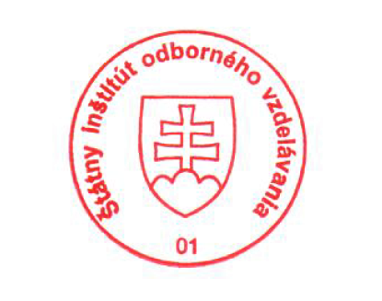 National Europass Centre
State Vocational Education Institute
Bellova 54/a,
837 63 Bratislava
europass@siov.sk
www.europass.sk

