1. Name of the Certificate ¹
Field of study 2860 K chemist operator
2. Translated title of the Certificate ²
Študijný odbor 2860 K chemik operátor (sk)
3. Profile of skills and competences
The holder of the certificate is able:
- to communicate correctly in the official language, both verbally and in writing,
- to communicate using one world language at least at the B1 level per the Common European Reference Framework,
- to adapt to changing living and working conditions, to work in a team and to take responsibility for tasks,
- to work with information, to use information and communication technologies and equipment,
- to apply basic mathematical relations and the laws of physics and chemistry when resolving practical tasks,
- to apply the principles of financial literacy, consumer protection and to understand business and the of work,
- to act environmentally with a view to a sustainable development strategy,
- to apply the principles of occupational health and safety and environmental protection,
- to explain chemical composition of processed raw materials, semi-finished and finished products, their properties and performance during the technological process, as well as their risk of toxicity and corrosivity, flammability, explosiveness and exhaustion,
- to operate machines and equipment of the relevant plant and ensure basic maintenance and optimal mode of their operation with regard to technological requirements, production effectiveness and minimizing the negative impact on the working and living environment,
- to perform sampling and apply basic analytical procedures, use them in relevant chemical processes, evaluate the obtained results and draw qualitative and quantitative conclusions from them,
- to measure the most important physical parameters using manual and instrumental methods and express them in the required units,
- to comply with relevant standards, standard procedures of analyses in relevant plants and laboratories and technological discipline in chemical production, to work with technical and technological documentation, to understand legal regulations in the field of chemistry and ensure their observance.
4. Range of occupations accessible to the holder of the certificate ³
Graduates find work as qualified workers in plants with chemical-technological processes, pharmaceutical production, oil and fuel processing, cellulose and paper processing, textile chemistry and other fields of industrial chemistry. Graduates operate machine technology equipment and are responsible for compliance with the production process under technology regulations, mark the finished product and semi-finished product in the prescribed manner, take samples for laboratory analyses. Examples of possible job positions: operator, dispatcher, technician, foreman, quality controller in the field of industrial chemistry.

5. Official basis of the certificate
Body awarding the certificate | Authority providing accreditation / recognition of the certificate
Ministry of Education, Science, Research and Sport of the Slovak Republic
Stromová 1
813 30 Bratislava
Phone: +421 2/59 374 111
www.minedu.sk
Level of the certificate (national or European)¹  Full secondary vocational education  SKQF/EQF 4  ISCED 354 | Grading scale / Pass requirements  1 – excellent  2 – praiseworthy  3 – good  4 – sufficient  5 – insufficient
Access to next level of education / training 1  Higher vocational education SKQF/EQF 5, ISCED 554  University, 1st degree, SKQF/EQF 6, ISCED 655, 645, 665  University, 2nd degree – SKQF/EQF 7, ISCED 766 | International agreements on the recognition of qualifications ¹
Legal basis
Act No. 245/2008 Coll. on Education and Training (Education Act) and on amendment of certain acts; Act No. 61/2015 Coll. on Vocational Education and Training and on amendment of certain acts; Decree of the Ministry of Education of the Slovak Republic no. 318/2008 Coll. on the completion of studies at secondary schools, as amended.
6. Officially recognised ways of acquiring the certificate
Successful completion of the four-year training program in the given field of study by passing the final examination.
7. Additional information
This Europass Certificate Supplement is valid together with the school leaving certificate issued by the relevant secondary school (the name and address of the school is specified on the certificate). In addition to the school leaving certificate, the school issues also the certificates of apprenticeship. More details about the education and training system are available at www.minedu.sk/data/files/7421.jpg, more details as to the organisation of the educational system are available at www.minedu.sk, and the details of educational programs are available at www.siov.sk and at the website of the specified school.
Entry requirements ¹
- lower secondary education, ISCED 244
- fulfilment of prerequisites in the admission procedure
More information (including a description of the national qualifications system)
Ministry of Education, Science, Research and Sport of the Slovak Republic, Study and Training Group
https://www.minedu.sk/18673-sk/studijne-a-ucebne-odbory-sauo/
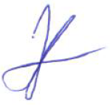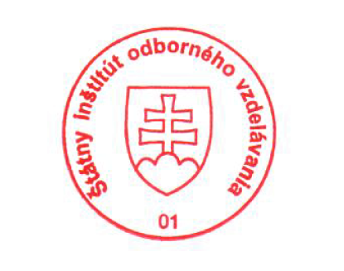 National Europass Centre
State Vocational Education Institute
Bellova 54/a,
837 63 Bratislava
europass@siov.sk
www.europass.sk

