1. Name of the Certificate ¹
Field of study 764 9 M teaching and education in kindergarten
2. Translated title of the Certificate ²
Študijný odbor 764 9 M učiteľstvo pre materské školy a vychovávateľstvo (sk)
3. Profile of skills and competences
The holder of the certificate is able to:
- to communicate correctly in the official language, both verbally and in writing,
- to communicate using one world language at least at the B1 level per the Common European Reference Framework,
- to adapt to changing living and working conditions, to work in a team and to take responsibility for assigned tasks,
- to work with information, to use information and communication technologies and equipment,
- to apply the principles of financial literacy,
- to act environmentally with regard to a sustainable development strategy,
- to apply basic legal rules, the principles of occupational health and safety and environmental protection,
- to provide basic first aid in response to accidents, small injuries and life-threatening conditions,
- to communicate with people sensitively and tactfully,
- to be involved in the creation of school education program for kindergarten and education program in school educational institutions,
- to plan and carry out educational activity in real conditions of kindergarten and school educational institution under the lead of an experienced pedagogue from practice,
- to integrate children with special educational needs with other children,
- to identify social cultural context of child’s development,
- to play on musical instruments (primary and secondary) in the scope of musical literature intended for pre-school and early school age and perform simple instrumental improvisation,
- to develop the principles of pre-reader, initial, scientific and mathematical literacy of pre-school children,
- to develop elementary musical and art skills of pre-school children,
- to apply motivational, activating and methods of education outside of educating children in school club,
- to develop effective means of learning of children, to develop autonomy of children in preparation for the school courses in the school club,
- to select and use forms and methods aimed at carrying out leisure activities in school educational institutions,
- to exercise and protect children's rights.
4. Range of occupations accessible to the holder of the certificate ³
Graduates find work in professions and job titles in pre-primary education and education outside school hours.
Examples of potential job titles include kindergarten teacher, educator in school educational institutions.

5. Official basis of the certificate
Body awarding the certificate | Authority providing accreditation / recognition of the certificate
Ministry of Education, Science, Research and Sport of the Slovak Republic
Stromová 1
813 30 Bratislava
Phone: +421 2/59 374 111
www.minedu.sk
Level of the certificate (national or European) ¹  Full secondary vocational education  SKQF/EQF 4  ISCED 354 | Grading scale / Pass requirements  1 – excellent  2 – praiseworthy  3 – good  4 – sufficient  5 – insufficient
Access to next level of education / training ¹  Higher vocational education, ISCED 554  University, 1st degree, ISCED 655, 645, 665  University, 2nd degree, ISCED 766 | International agreements on recognition of qualifications¹
Legal basis
Act No. 245/2008 Coll. on Education and Training (Education Act) and on amendment of certain acts; Act No. 61/2015 Coll. on Vocational Education and Training and on amendment of certain acts; Decree of the Ministry of Education of the Slovak Republic no. 318/2008 Coll. on the completion of studies at secondary schools, as amended.
6. Officially recognised ways of acquiring the certificate
Successful completion of the four-year training program in the given field of study by passing the school leaving examination.
7. Additional information
After successful completion of the training program in the given field of study the graduates receive a certificate confirming their passing of the school leaving examination.
Entry requirements ¹
- lower secondary education ISCED 244
- fulfilment of prerequisites in the admission procedure
More information (including a description of the national qualifications system)
Ministry of Education, Science, Research and Sport of the Slovak Republic, Study and Training Group
https://www.minedu.sk/18673-sk/studijne-a-ucebne-odbory-sauo/
National Europass Centre
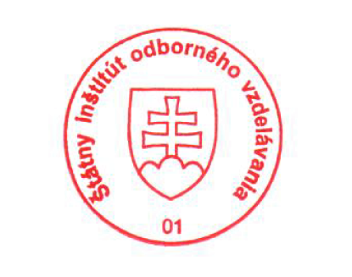
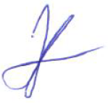
State Vocational Education Institute
Bellova 54/a,
837 63 Bratislava
europass@siov.sk
www.europass.sk

