1. Name of the Certificate ¹
Field of study 6851 N social legal activity (post-secondary education qualification)
2. Translated title of the Certificate ²
Študijný odbor 6851 N sociálno-právna činnosť (pomaturitné kvalifikačné štúdium) (sk)
3. Profile of skills and competences
The holder of the certificate is able to:
- to communicate using at least one world language at the B1 level per the Common European Reference Framework, to apply vocabulary in the scope of the determined specialized topics,
- to adapt to changing living and working conditions, to work in a team and to take responsibility for assigned tasks,
- to work with information, to use information and communication technologies and equipment,
- to apply the principles of financial literacy, consumer protection and to understand business and the world of work,
- to act environmentally with regard to a sustainable development strategy,
- to apply basic legal rules, the principles of occupational health and safety and environmental protection,
- to provide basic first aid in response to accidents, small injuries and life-threatening conditions,
- to distinguish the peculiarities and differences of social environment,
- to understand basic legal concepts and principles, to be knowledgeable in civil, family and labour law, social security law,
- to use basic accounting and to know the principles of double-entry bookkeeping,
- to use professional documentation in the field,
- to plan, organise and evaluate one's own professional activities,
- to gain, classify, assess and use information on client and client’s environment, to responsibly handle information,
- to design appropriate social measures of social-legal protection for particular clients,
- to create factually, stylistically and grammatically correct written documents of work and personal character,
- to master practical skills of work with office technology,
- to apply knowledge of mental hygiene, methods and techniques of self-knowledge, self-regulation, self-discipline to handle stress and occupational hazards,
- to apply basic human and social rights,
- to apply ethical professional principles in behaviour and actions.
4. Range of occupations accessible to the holder of the certificate ³
Graduates find work in professions and job titles in state administration in the field of state social benefits, benefits to offset the social consequences of severe disability, emergency benefit, information, advisory and intermediation services, active labour market measures, in institutions of self-government as an employee of municipality for lone citizens, seniors and social services, for social assistance to families with dependent children, social-legal protection and social curatorship, in institutions and organisations of the third sector, in the field of social insurance, in the field of justice, notarial profession, in the enterprise sphere.

5. Official basis of the certificate
Body awarding the certificate | Authority providing accreditation / recognition of the certificate
Ministry of Education, Science, Research and Sport of the Slovak Republic
Stromová 1
813 30 Bratislava
Phone: +421 2/59 374 111
www.minedu.sk
Level of the certificate (national or European) ¹  Full secondary vocational education  SKQF/EQF 4  ISCED 454 | Grading scale / Pass requirements  1 – excellent  2 – praiseworthy  3 – good  4 – sufficient  5 – insufficient
Access to next level of education / training ¹  Higher vocational education, ISCED 554  University, 1st degree, ISCED 655, 645, 665  University, 2nd degree, ISCED 766 | International agreements on recognition of qualifications¹
Legal basis
Act No. 245/2008 Coll. on Education and Training (Education Act) and on amendment of certain acts; Act No. 61/2015 Coll. on Vocational Education and Training and on amendment of certain acts; Decree of the Ministry of Education of the Slovak Republic no. 318/2008 Coll. on the completion of studies at secondary schools, as amended.
6. Officially recognised ways of acquiring the certificate
Successful completion of the four-year training program in the given field of study by passing the school leaving examination.
7. Additional information
After successful completion of the training program in the given field of study the graduates receive a certificate confirming their passing of the school leaving examination.
Entry requirements ¹
- complete secondary general education, ISCED 344
- complete secondary education, ISCED 354
- fulfilment of prerequisites in the admission procedure
More information (including a description of the national qualifications system)
Ministry of Education, Science, Research and Sport of the Slovak Republic, Study and Training Group
https://www.minedu.sk/18673-sk/studijne-a-ucebne-odbory-sauo/
National Europass Centre
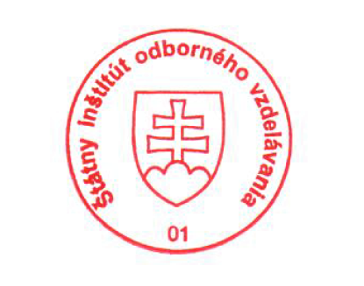
State Vocational Education Institute
Bellova 54/a,
837 63 Bratislava
europass@siov.sk
www.europass.sk

