1. Name of the Certificate ¹
Field of study 7670 M pedagogical assistant
2. Translated title of the Certificate ²
Študijný odbor 7670 M pedagogický asistent (sk)
3. Profile of skills and competences
The holder of the certificate is able to:
- to communicate correctly in the official language, both verbally and in writing,
- to communicate using one world language at least at the B1 level per the Common European Reference Framework,
- to adapt to changing living and working conditions, to work in a team and to take responsibility for assigned tasks,
- to work with information, to use information and communication technologies and equipment,
- to apply the principles of financial literacy,
- to act environmentally with regard to a sustainable development strategy,
- to apply basic legal rules, the principles of occupational health and safety and environmental protection,
- to provide basic first aid in response to accidents, small injuries and life-threatening conditions,
- to communicate with people sensitively and tactfully,
- to design, organise, carry out and evaluate educational and leisure activities according to the instructions of the teacher,
- to identify psychological and social factors and learning styles of children and students,
- to integrate children and students with special educational needs with other children and students,
- to help children and students in learning the curriculum and required competences and in preparation for the school courses,
- to create conditions necessary to overcome language, cultural and social barriers of children and students while ensuring educational process,
- to develop social skills, approaches and cultural identity of children and students,
- to develop self-care activities of disabled children and students necessary to handle regular operations during curricular and extra-curricular activities,
- to help children and students coming from diverse cultural or disadvantaged social backgrounds to adapt to school environment and deal with educational requirements,
- to plan, organise and carry out leisure activities for children and students (singing, musical, physical, art, dramatic and other activities),
- to exercise and protect children's rights.
4. Range of occupations accessible to the holder of the certificate ³
Graduates find work as pedagogical employees at schools and educational institutions.
Examples of potential job titles include: teaching assistants, educator's assistant and assistant of master in vocational education.

5. Official basis of the certificate
Body awarding the certificate | Authority providing accreditation / recognition of the certificate
Ministry of Education, Science, Research and Sport of the Slovak Republic
Stromová 1
813 30 Bratislava
Phone: +421 2/59 374 111
www.minedu.sk
Level of the certificate (national or European) ¹  Full secondary vocational education  SKQF/EQF 4  ISCED 354 | Grading scale / Pass requirements  1 – excellent  2 – praiseworthy  3 – good  4 – sufficient  5 – insufficient
Access to next level of education / training ¹  Higher vocational education, ISCED 554  University, 1st degree, ISCED 655, 645, 665  University, 2nd degree, ISCED 766 | International agreements on recognition of qualifications¹
Legal basis
Act No. 245/2008 Coll. on Education and Training (Education Act) and on amendment of certain acts; Act No. 61/2015 Coll. on Vocational Education and Training and on amendment of certain acts; Decree of the Ministry of Education of the Slovak Republic no. 318/2008 Coll. on the completion of studies at secondary schools, as amended.
6. Officially recognised ways of acquiring the certificate
Successful completion of the four-year training program in the given field of study by passing the school leaving examination.
7. Additional information
After successful completion of the training program in the given field of study the graduates receive a certificate confirming their passing of the school leaving examination.
Entry requirements ¹
- lower secondary education ISCED 244
- fulfilment of prerequisites in the admission procedure
More information (including a description of the national qualifications system)
Ministry of Education, Science, Research and Sport of the Slovak Republic, Study and Training Group
https://www.minedu.sk/18673-sk/studijne-a-ucebne-odbory-sauo/
National Europass Centre
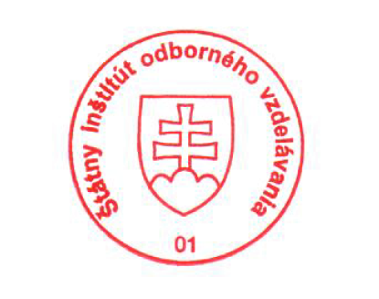
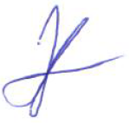
State Vocational Education Institute
Bellova 54/a,
837 63 Bratislava
europass@siov.sk
www.europass.sk

