1. Name of the Certificate ¹
Field of study 7661 M social educational worker
2. Translated title of the Certificate ²
Študijný odbor 7661 M sociálno-výchovný pracovník (sk)
3. Profile of skills and competences
The holder of the certificate is able to:
- to communicate correctly in the official language, both verbally and in writing,
- to communicate using one world language at least at the B1 level per the Common European Reference Framework,
- to adapt to changing living and working conditions, to work in a team and to take responsibility for assigned tasks,
- to work with information, to use information and communication technologies and equipment,
- to apply the principles of financial literacy,
- to act environmentally with regard to a sustainable development strategy,
- to apply basic legal rules, the principles of occupational health and safety and environmental protection,
- to communicate with people sensitively and tactfully,
- to provide basic first aid in response to accidents, small injuries and life-threatening conditions,
- to understand the system of social care for targeted groups of persons,
- to specify and analyse social policy of the state, its system and tools,
- to introduce the content and meaning of legal rules regarding provision of help to individual population groups,
- to apply knowledge acquired from pedagogy and psychology into practice,
- to apply specifics of educational and social work with people coming from a disadvantaged social background, with people with health disadvantage,
- to design solution regarding care for family, children, youth, risk groups,
- to cooperate with specialists from educational, training, advisory, health and social institutions,
- to plan, organize, carry out and evaluate educational activities,
- to create programs of leisure activities for children/students/clients of various age categories,
- to apply skills of pedagogy and social communication,
- to create factually, stylistically and grammatically correct written documents of work character,
- to apply knowledge of mental hygiene, methods and techniques of self-knowledge, self-regulation, self-discipline to handle stress and occupational hazards,
- to exercise and protect human rights.

4. Range of occupations accessible to the holder of the certificate ³
Graduates find work in professions and job titles in the field of education outside school hours, mainly in social assistance institutions. Graduates find work in job titles in state and local administration.
Examples of potential job titles: educator in social assistance institutions (educator in social-legal protection and social curatorship bodies, educator in social services institutions).

5. Official basis of the certificate
Body awarding the certificate | Authority providing accreditation / recognition of the certificate
Ministry of Education, Science, Research and Sport of the Slovak Republic
Stromová 1
813 30 Bratislava
Phone: +421 2/59 374 111
www.minedu.sk
Level of the certificate (national or European) ¹  Full secondary vocational education  SKQF/EQF 4  ISCED 354 | Grading scale / Pass requirements  1 – excellent  2 – praiseworthy  3 – good  4 – sufficient  5 – insufficient
Access to next level of education / training ¹  Higher vocational education, ISCED 554  University, 1st degree, ISCED 655, 645, 665  University, 2nd degree, ISCED 766 | International agreements on recognition of qualifications¹
Legal basis
Act No. 245/2008 Coll. on Education and Training (Education Act) and on amendment of certain acts; Act No. 61/2015 Coll. on Vocational Education and Training and on amendment of certain acts; Decree of the Ministry of Education of the Slovak Republic no. 318/2008 Coll. on the completion of studies at secondary schools, as amended.
6. Officially recognised ways of acquiring the certificate
Successful completion of the four-year training program in the given field of study by passing the school leaving examination.
7. Additional information
After successful completion of the training program in the given field of study the graduates receive a certificate confirming their passing of the school leaving examination.
Entry requirements ¹
- lower secondary education ISCED 244
- fulfilment of prerequisites in the admission procedure
More information (including a description of the national qualifications system)
Ministry of Education, Science, Research and Sport of the Slovak Republic, Study and Training Group
https://www.minedu.sk/18673-sk/studijne-a-ucebne-odbory-sauo/
National Europass Centre
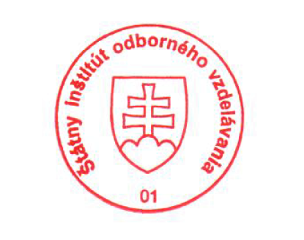
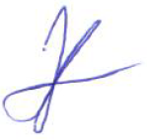
State Vocational Education Institute
Bellova 54/a,
837 63 Bratislava
europass@siov.sk
www.europass.sk

