1. Name of the Certificate ¹
Field of study 7647 3 caregiver
2. Translated title of the Certificate ²
Študijný odbor 7647 3 opatrovateľka (sk)
3. Profile of skills and competences
The holder of the certificate is able to:
- to act independently in social and professional life,
- to express themselves in the official language and one foreign language in written and spoken form,
- to apply the basic principles of financial literacy, consumer protection and to understand business and the world of work,
- to use information and communication technologies to solve practical tasks,
- to work in diverse groups, to cooperate in a team, to organise their work,
- to act environmentally with regard to a sustainable development strategy,
- to apply the principles of occupational safety, health and environmental protection,
- to select the most effective process of performing nursing care,
- to provide nursing care for the client at home and in institutions independently, in the scope determined by applicable regulations of the Ministry of Labour, Social Affairs and Family of the Slovak Republic,
- to provide first aid in response to accidents and injuries,
- to perform the essential housework,
- to ensure client’s contact with social environment,
- to cooperate with specialists from educational, training, advisory, health and social institutions,
- to help treat basic health problems of the client,
- to communicate with clients tactfully,
- to apply the basics of food hygiene, to store the main ingredients for the preparation of meals and drinks correctly,
- to prepare basic types of meals,
- to use and fill in the forms in social security,
- to handle basic methods of handiwork.
4. Range of occupations accessible to the holder of the certificate ³
Graduates find work as professionally qualified workers in social services institutions, where the care is provided daily, weekly or throughout the year, in home nursing care for clients of various age categories.
Examples of potential job titles include caregiver in social service institution, caregiver in household.

5. Official basis of the certificate
Body awarding the certificate | Authority providing accreditation / recognition of the certificate
Ministry of Education, Science, Research and Sport of the Slovak Republic
Stromová 1
813 30 Bratislava
Phone: +421 2/59 374 111
www.minedu.sk
Level of the certificate (national or European) ¹  Secondary vocational education without school leaving certificate and certificates of apprenticeship  SKQF/EQF 3  ISCED 353 | Grading scale / Pass requirements  1 – excellent  2 – praiseworthy  3 – good  4 – sufficient  5 – insufficient
Access to next level of education / training ¹  Advanced study educational programmes for graduates of the 3-year field of study  SKQF/EQF 4, ISCED 454 | International agreements on recognition of qualifications¹
Legal basis
Act No. 245/2008 Coll. on Education and Training (Education Act) and on amendment of certain acts; Act No. 61/2015 Coll. on Vocational Education and Training and on amendment of certain acts; Decree of the Ministry of Education of the Slovak Republic no. 318/2008 Coll. on the completion of studies at secondary schools, as amended.
6. Officially recognised ways of acquiring the certificate
Successful completion of the four-year training program in the given field of study by passing the school leaving examination.
7. Additional information
After successful completion of the training program in the given field of study the graduates receive a certificate confirming their passing of the school leaving examination.
Entry requirements ¹
- completion of 9th year of primary school
- demonstration of required knowledge prerequisites via admission procedure
More information (including a description of the national qualifications system)
Ministry of Education, Science, Research and Sport of the Slovak Republic, Study and Training Group
https://www.minedu.sk/18673-sk/studijne-a-ucebne-odbory-sauo/
National Europass Centre
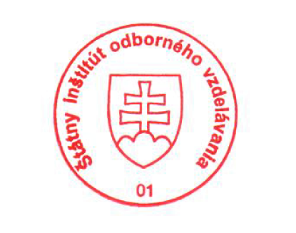
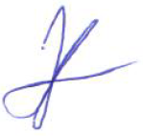
State Vocational Education Institute
Bellova 54/a,
837 63 Bratislava
europass@siov.sk
www.europass.sk

