1. Title of the certificate ¹
Field of Study 6425 K Beautician
2 . Translated title of the certificate ²
Študijný odbor 6425 K Vizážista (sk)
3. Profile of skills and competences
The holder of the certificate is able to:
- apply the principles of occupational health and safety AND hygiene regulations applicable to cosmetology services,
- apply all principles, operating rules, disinfection, pest control, sterilization and its types,
- assess skin condition and use diagnostics to determine skin type,
- apply the correct work procedure based on skin condition and skin type,
- apply the correct work procedure when applying makeup,
- apply work principles intended to achieve the best possible outcome in terms of changing the client’s appearance and their personal harmony skin colour, eye colour and mouth, and the natural proportions of their face, eyes, mouth and nose,
- exploit colour combinations and to use them in accordance with colour typology,
- apply make-up artist tricks when applying makeup and to apply face, eye, mouth and nose correction,
- apply techniques for applying make-up, eye shadow, eye liner, masks, grafting and glueing on eyelashes,
applying make-up to the mouth, applying powder, fixation /,
- apply thematic make-up (day make-up, evening make-up,
- remove unwanted hair from the upper lip by bleaching or using depilatory procedures,
- modify the eyebrows using tweezers, eye shadow, eye liner,
- dye the eyebrows and eyelashes,
- choose and apply appropriate masks, and skin creams to treat the skin in within treatment steps,
- give face, neck, and décolletage massage,
- aesthetically adjust skin and hair as part of overall care for personal harmony.

4. Range of occupations accessible to the holder of the certificate ³
Graduates find work in cosmetic, hairdressing and makeup salons, in shops with hairdressing and cosmetology products, in modelling, theatres and television stations. They find work in companies providing consulting services covering adjustments and changes in appearance and overall appearance.

5. Official basis of the certificate
Body awarding the certificate | Authority providing accreditation / recognition of the certificate
Ministry of Education, Science, Research and Sport of the Slovak Republic
Stromová 1
813 30 Bratislava
Phone: +421 2/59 374 111
www.minedu.sk
Level of the certificate (national or European) ¹ | Grading scale / Pass requirement
SKKR/EKR: 4 | Pass  Fail
Access to next level of education / training ¹ | International agreements on recognition of qualifications ¹
Legal basis
Act No. 568/2009 Coll. on Lifelong Education and on amendment of certain acts, as amended and Decree No. 97/2010 Coll. as amended
6. Officially recognized ways of acquiring the certificate
Completion of an accredited training program in the scope of 160 hours.
Demonstration of professional experience

7. Additional information
Entry requirements ¹
More information (including a description of the national qualifications system)
More information is provided at www.minedu.sk, in the section of Lifelong Education, Further Education Information System, Testing to verify professional qualifications http://isdv.iedu.sk/Eligibility.aspx and on the website of the relevant holder of certification to verify professional qualifications.

National Europass Centre
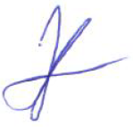
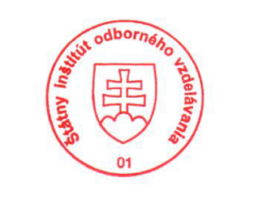
State Vocational Education Institute
Bellova 54/a,
837 63 Bratislava
europass@siov.sk
www.europass.sk

