1. Title of the certificate ¹
Field of Study 6456 H Barber
2 . Translated title of the certificate ²
Študijný odbor 6456 H Pánsky kaderník - Holič (sk)
3. Profile of skills and competences
The holder of the certificate is able to:
- apply the principles of occupational health and safety AND hygiene regulations applicable to hairdressing services,
- follow all operating rules, principles of disinfection, pest control, sterilization and its types,
- assess scalp condition and use diagnostics to determine hair type,
- use hairdressing devices, tools and materials for individual hairdressing activities (razor, clippers),
- wash hair using suitable shampoos matched to hair type,
- give scalp massages using various techniques both manually and using electric devices,
- impart water wave and blow dried wave shapes, to shape hair into a hairstyle,
- apply hairstyles for fashionable, social, wedding and competitive purposes,
- apply various technological processes and techniques for cutting hair,
- define diagnoses for hair, moustaches and beards,
- apply water wave techniques: drying, drying through the fingers, drying into a hairstyle, blow dried wave shapes,
- shape hair into a hairstyle, to apply a fashion hairstyle, to create a unique personalised hairstyle,
- apply the technical procedures for shaving men,
- apply the technical procedures to trim moustaches and beards,
- apply fashion trends in dyeing hair, moustaches and beards,
- care for hair, moustaches and beards after dyeing and bleaching,
- apply new dyeing preparations and technical procedures per the manufacturer’s instructions,
- apply the latest working methods for dyeing hair, moustaches and beards,
- apply suitable cosmetic and regenerative hair, moustache and beard care products and use them according to good technological practices.

4. Range of occupations accessible to the holder of the certificate ³
Graduates find work in hair studios and hairdressing salons, in hotels and treatment facilities, and in the hairdressing workshops of television stations, theatres and so on to style men's hair, moustaches and beards. They also work in companies that deal in hair care products and provide counselling services.

5. Official basis of the certificate
Body awarding the certificate | Authority providing accreditation / recognition of the certificate
Ministry of Education, Science, Research and Sport of the Slovak Republic
Stromová 1
813 30 Bratislava
Phone: +421 2/59 374 111
www.minedu.sk
Level of the certificate (national or European) ¹ | Grading scale / Pass requirement
SKKR/EKR: 4 | Pass  Fail
Access to next level of education / training ¹ | International agreements on recognition of qualifications ¹
Legal basis
Act No. 568/2009 Coll. on Lifelong Education and on amendment of certain acts, as amended and Decree No. 97/2010 Coll. as amended
6. Officially recognized ways of acquiring the certificate
Completion of an accredited training program in the scope of 350 hours.
Demonstration of professional experience

7. Additional information
Entry requirements ¹
More information (including a description of the national qualifications system)
More information is provided at www.minedu.sk, in the section of Lifelong Education, Further Education Information System, Testing to verify professional qualifications http://isdv.iedu.sk/Eligibility.aspx and on the website of the relevant holder of certification to verify professional qualifications.

National Europass Centre
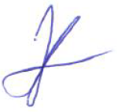
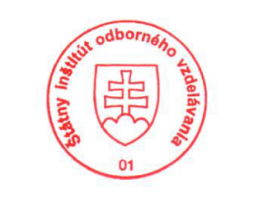
State Vocational Education Institute
Bellova 54/a,
837 63 Bratislava
europass@siov.sk
www.europass.sk

