1. Name of the Certificate ¹
Field of study 3446 K print media graphic designer
2. Translated title of the Certificate ²
Grafik tlačových médií (sk)
3. Profile of skills and competences
The holder of the certificate is able to:
- prepare a work plan and determine the procedure for processing input data based on the parameters of the assigned order and the technological regulation,
- retrieve text and graphic data from external sources and prepare them for processing,
- scan image templates and prepare them for further processing,
- work with a digital camera,
- work with data files,
- work with bitmap and vector programs for image and text processing,
- perform colour and gradation adjustment of image templates according to the assignment in the technological regulation,
- typographically modify the text and page breaks according to the technological regulation,
- make an electronic assembly,
- process the complete preparation and checks of output data for further order processing,
- prepare the output data of the order to create a printing form via CTP,
- prepare output data of the order necessary for digital printing,
- work with CTP equipment and technologies for the production of printed media,
- work with cutting and printing plotters,
- operate digital printing machines,
- actively use the standards and guidelines applicable to the printing industry,
- appropriately use individual types of materials, respect the prescribed methods of storage and handling of materials,
- perform graphic design of printed media,
- observe the parameters of individual types of products,
- perform input, inter-operational and output control,
- observe the principles of safety at work and occupational hygiene,
- apply the principles of environmental protection.
4. Range of occupations accessible to the holder of the certificate ³
The graduate can find employment as a graphic or CTP operator in the field of producing printed media by all available printing technologies, in work activities related to the operation of the most modern electronically controlled technologies for creating printed media. The graduate can also be employed in advertising agencies and graphic studios with digital print or for defining the most suitable printing techniques for the given type of graphic product and in professional assessment of print quality. Furthermore, the graduate can be employed in a publishing house as a production manager.
Examples of possible job positions: graphic, CTP operator.

5. Official basis of the certificate
Body awarding the certificate | Authority providing accreditation / recognition of the certificate
Ministry of Education, Science, Research and Sport of the Slovak Republic
Stromová 1
813 30 Bratislava
Phone: +421 2/59 374 111
www.minedu.sk
Level of the certificate (national or European) ¹  Full secondary vocational education  SKQF/EQF: 4  ISCED 354 | Grading scale / Pass requirements  1 – excellent  2 – praiseworthy  3 – good  4 – sufficient  5 – insufficient
Access to next level of education / training ¹  University, 1st degree, ISCED 655, 645, 665  University, 2nd degree, ISCED 766, 767 | International agreements on the recognition of qualifications ¹
Legal basis
Act No. 245/2008 Coll. on Education and Training (Education Act) and on amendment of certain acts; Act No. 61/2015 Coll. on Vocational Education and Training and on amendment of certain acts; Decree of the Ministry of Education of the Slovak Republic no. 318/2008 Coll. on the completion of studies at secondary schools, as amended.
6. Officially recognised ways of acquiring the certificate
Successful completion of the four-year training program in the given field of study by passing the school leaving examination.
7. Additional information
After successful completion of the training program in the given field of study the graduates receive a certificate confirming their passing of the school leaving examination and a vocational certificate.
Entry requirements ¹
- lower secondary education, ISCED 244
- fulfilment of prerequisites in the admission procedure
More information (including a description of the national qualifications system)
Ministry of Education, Science, Research and Sport of the Slovak Republic, Study and Training Group
https://www.minedu.sk/18673-sk/studijne-a-ucebne-odbory-sauo/
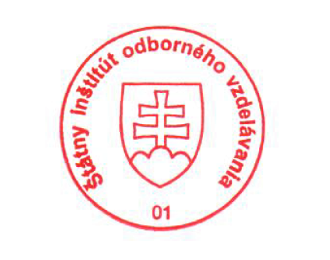 National Europass Centre
State Vocational Education Institute
Bellova 54/a,
837 63 Bratislava
europass@siov.sk
www.europass.sk

