1. Name of the Certificate ¹
Field of study 3436 K bindery operator, book binding operator, bindery machine operator
2. Translated title of the Certificate ²
Operátor knihárskych technológií (sk)
3. Profile of skills and competences
The holder of the certificate is able to:
- prepare a work plan and determine the procedure based on the parameters of the assigned order and the production documents,
- prepare bookbinding materials and determine a work plan,
- use working tools, implements and devices necessary for setting up the bookbinding machine and the bookbinding line,
- select, set and evaluate the parameters of bookbinding machines and equipment and bookbinding production lines by using automation elements, computer technology and control programs of bookbinding production lines,
- perform simple maintenance and eliminate simple faults on bookbinding machines and equipment,
- process soft bindings and hard book bindings on single-purpose bookbinding machines and on bookbinding lines,
- perform inspection and qualitative tests of bookbinding products,
- record and document technical data about the work progress and work results,
- perform bookbinding work while taking into account the relevant safety regulations, standards of printing production,
- master basic and special bookbinding techniques and technologies, observe the technological theory,
- observe the principles of safety at work and occupational hygiene,
- apply the principles of environmental protection.
4. Range of occupations accessible to the holder of the certificate ³
The graduate can find employment in the field of finishing of printed media and in the field of bookbinding production in work activities related to the operation of the most modern electronically controlled bookbinding technologies.
Examples of possible job positions: technician for final processing, bookbinding technology operator, bookbinder.

5. Official basis of the certificate
Body awarding the certificate | Authority providing accreditation / recognition of the certificate
Ministry of Education, Science, Research and Sport of the Slovak Republic
Stromová 1
813 30 Bratislava
Phone: +421 2/59 374 111
www.minedu.sk
Level of the certificate (national or European) ¹  Full secondary vocational education  SKQF/EQF: 4  ISCED 354 | Grading scale / Pass requirements  1 – excellent  2 – praiseworthy  3 – good  4 – sufficient  5 – insufficient
Access to next level of education / training ¹  University, 1st degree, ISCED 655, 645, 665  University, 2nd degree, ISCED 766, 767 | International agreements on the recognition of qualifications ¹
Legal basis
Act No. 245/2008 Coll. on Education and Training (Education Act) and on amendment of certain acts; Act No. 61/2015 Coll. on Vocational Education and Training and on amendment of certain acts; Decree of the Ministry of Education of the Slovak Republic no. 318/2008 Coll. on the completion of studies at secondary schools, as amended.
6. Officially recognised ways of acquiring the certificate
Successful completion of the four-year training program in the given field of study by passing the school leaving examination.
7. Additional information
After successful completion of the training program in the given field of study the graduates receive a certificate confirming their passing of the school leaving examination and a vocational certificate.
Entry requirements ¹
- lower secondary education, ISCED 244
- fulfilment of prerequisites in the admission procedure
More information (including a description of the national qualifications system)
Ministry of Education, Science, Research and Sport of the Slovak Republic, Study and Training Group
https://www.minedu.sk/18673-sk/studijne-a-ucebne-odbory-sauo/
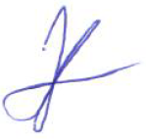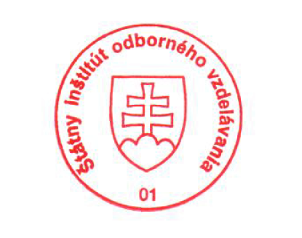 National Europass Centre
State Vocational Education Institute
Bellova 54/a,
837 63 Bratislava
europass@siov.sk
www.europass.sk

