1. Name of the Certificate ¹
Field of study 3432 M packaging technician
2. Translated title of the Certificate ²
Obalová technika (sk)
3. Profile of skills and competences
The holder of the certificate is able to:
- master the basics of technical drawings for designing and constructing packaging,
- use software for designing and constructing packaging,
- apply the knowledge of basic computer software for the creation of text and graphics for the construction and editing of packaging,
- master the graphic design of packaging, its functions, materials and conditions of its implementation,
- measure the colour deviation with a densitometer and a spectrophotometer,
- use systems for protective packaging,
- use and comply with the standards for using packaging materials,
- perform input, inter-operational and output controls of raw materials, production materials, semi-finished products and products in packaging production,
- know the basics and importance of information systems in the company for evaluating the success of its results,
- use basic knowledge in the field of marketing and management, psychology, sociology and ecology,
- observe the principles of safety at work and occupational hygiene,
- accurately express himself in both written and oral form using technical terminology,

4. Range of occupations accessible to the holder of the certificate ³
The graduate can find employment in the field of packaging design and in the field of production of packaging and packaging materials by all available production techniques. The graduate can also be employed in advertising agencies and graphic studios with packaging design or for defining the most suitable production and printing techniques for the given type of packaging and in professional assessment of the packaging quality.
Examples of possible job positions: packer, foreman in packaging production, quality controller for packaging, packaging technician, packaging designer.

5. Official basis of the certificate
Body awarding the certificate | Authority providing accreditation / recognition of the certificate
Ministry of Education, Science, Research and Sport of the Slovak Republic
Stromová 1
813 30 Bratislava
Phone: +421 2/59 374 111
www.minedu.sk
Level of the certificate (national or European) ¹  Full secondary vocational education  SKQF/EQF: 4  ISCED 354 | Grading scale / Pass requirements  1 – excellent  2 – praiseworthy  3 – good  4 – sufficient  5 – insufficient
Access to next level of education / training ¹  University, 1st degree, ISCED 655, 645, 665  University, 2nd degree, ISCED 766, 767 | International agreements on the recognition of qualifications ¹
Legal basis
Act No. 245/2008 Coll. on Education and Training (Education Act) and on amendment of certain acts; Act No. 61/2015 Coll. on Vocational Education and Training and on amendment of certain acts; Decree of the Ministry of Education of the Slovak Republic no. 318/2008 Coll. on the completion of studies at secondary schools, as amended.
6. Officially recognised ways of acquiring the certificate
Successful completion of the four-year training program in the given field of study by passing the school leaving examination.
7. Additional information
After successful completion of the training program in the given field of study the graduates receive a certificate confirming their passing of the school leaving examination.
Entry requirements ¹
- lower secondary education, ISCED 244
- fulfilment of prerequisites in the admission procedure
More information (including a description of the national qualifications system)
Ministry of Education, Science, Research and Sport of the Slovak Republic, Study and Training Group
https://www.minedu.sk/18673-sk/studijne-a-ucebne-odbory-sauo/
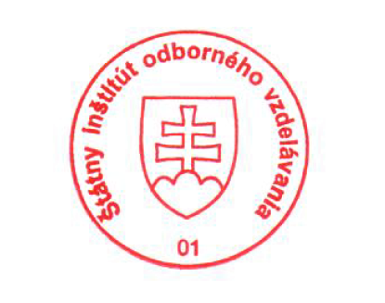 National Europass Centre
State Vocational Education Institute
Bellova 54/a,
837 63 Bratislava
europass@siov.sk
www.europass.sk

