1. Name of the Certificate ¹
Field of study 3431 M 01 Polygraphic Industry – Polygraphic Technology
2. Translated title of the Certificate ²
Polygrafia – polygrafická technológia (sk)
3. Profile of skills and competences
The holder of the certificate is able to:
- prepare a work plan and determine the procedure for processing input data based on the parameters of the assigned order,
- retrieve text data from external sources and prepare them for processing,
- scan image templates and prepare them for further processing,
- prepare the necessary materials for completing the order and its logistical support,
- prepare technological regulations for individual technological operations of polygraphic production for the production of specified printed media,
- design optimal technological procedures for the completion of the order while taking into account the requirements of the order and the effective use of available technologies, technical and technological equipment and materials,
- calculate the expenses, time and financial necessities of the operation for the completion of the order,
- manage individual technological production operations for polygraphic production,
- master and be able to use inter-operational procedures and output controls for the management of production operations,
- process and use technological and operational documentation,
- use the standards applicable to polygraphic production,
- determine the use of polygraphic equipment and technologies necessary for the order completion,
- use professional terminology in communication and when solving practical tasks,
- have a grasp of the management and marketing in the field of polygraphic production,
- observe the principles of safety at work and occupational hygiene,
- apply the principles of environmental protection.
4. Range of occupations accessible to the holder of the certificate ³
The graduate can find employment in professions in the field of producing printed media by all available printing technologies, in work activities related to the operation of the most modern electronically controlled printing technologies. The graduate can also be employed in advertising agencies and graphic studios for defining the most suitable printing techniques for the given type of graphic product and in professional assessment of print quality. Furthermore, the graduate can be employed in a publishing house as a production manager.
Examples of possible job positions: polygraph, foreman of the production centre, cost clerk, quality controller, sales and marketing employee in polygraphic production, employee in logistics of polygraphic production, marketing employee in polygraphy, project manager in polygraphy.

5. Official basis of the certificate
Body awarding the certificate | Authority providing accreditation / recognition of the certificate
Ministry of Education, Science, Research and Sport of the Slovak Republic
Stromová 1
813 30 Bratislava
Phone: +421 2/59 374 111
www.minedu.sk
Level of the certificate (national or European) ¹  Full secondary vocational education  SKQF/EQF: 4  ISCED 354 | Grading scale / Pass requirements  1 – excellent  2 – praiseworthy  3 – good  4 – sufficient  5 – insufficient
Access to next level of education / training ¹  University, 1st degree, ISCED 655, 645, 665  University, 2nd degree, ISCED 766, 767 | International agreements on recognition of qualifications¹
Legal basis
Act No. 245/2008 Coll. on Education and Training (Education Act) and on amendment of certain acts; Act No. 61/2015 Coll. on Vocational Education and Training and on amendment of certain acts; Decree of the Ministry of Education of the Slovak Republic no. 318/2008 Coll. on the completion of studies at secondary schools, as amended.
6. Officially recognised ways of acquiring the certificate
Successful completion of the four-year training program in the given field of study by passing the school leaving examination.
7. Additional information
After successful completion of the training program in the given field of study the graduates receive a certificate confirming their passing of the school leaving examination.
Entry requirements ¹
- lower secondary education, ISCED 244
- fulfilment of prerequisites in the admission procedure
More information (including a description of the national qualifications system)
Ministry of Education, Science, Research and Sport of the Slovak Republic, Study and Training Group
https://www.minedu.sk/18673-sk/studijne-a-ucebne-odbory-sauo/
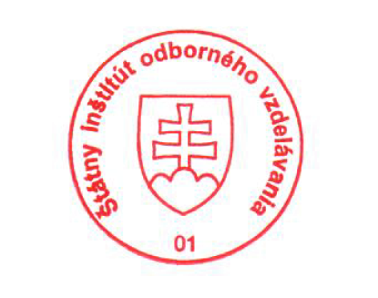 National Europass Centre
State Vocational Education Institute
Bellova 54/a,
837 63 Bratislava
europass@siov.sk
www.europass.sk

