1. Name of the Certificate ¹
Field of study 3473 H 07 polygraph - printer
2. Translated title of the Certificate ²
Polygraf - tlačiar (sk)
3. Profile of skills and competences
The holder of the certificate is able to:
- prepare printing equipment and set up printing machines,
- prepare printing inks and other materials, templates and aids for polygraphic production,
- comply with the standards for using polygraphic materials, norms and guidelines for polygraphic production,
- regulate the printing process and eliminate basic errors arising in the printing process,
- check the graphics and text for completed semi-finished products and products in polygraphic production,
- operate printing machines that do not use the most modern electronically controlled printing systems,
- perform checks of page disposals for print sheets with following bookbinding processing,
- use polygraphic terminology,
- use basic densitometer and spectrophotometer measurement techniques,
- check the operability of the printing machine,
- check, operate, maintain and clean printing equipment,
- perform basic input, inter-operational and output control of raw materials, production materials, semi-finished products and products in polygraphic production,
- observe the principles of safety at work and occupational hygiene,
- apply the principles of environmental protection.
4. Range of occupations accessible to the holder of the certificate ³
The graduate can find employment as a printer or print operator in the field of production of printed media by applying basic available printing techniques, in work activities related to the operation of printing technologies that do not use the most modern electronically controlled printing systems.
Examples of possible job positions: printer, print operator.

5. Official basis of the certificate
Body awarding the certificate | Authority providing accreditation / recognition of the certificate
Ministry of Education, Science, Research and Sport of the Slovak Republic
Stromová 1
813 30 Bratislava
Phone: +421 2/59 374 111
www.minedu.sk
Level of the certificate (national or European) ¹  Secondary vocational education  SKQF/EQF: 3  ISCED 353 | Grading scale / Pass requirements  1 – excellent  2 – praiseworthy  3 – good  4 – sufficient  5 – insufficient
Access to next level of education / training ¹  Complete secondary vocational education, ISCED 354  University, 1st degree, ISCED 655, 645, 665  University, 2nd degree, ISCED 766, 767 | International agreements on the recognition of qualifications ¹
Legal basis
Act No. 245/2008 Coll. on Education and Training (Education Act) and on amendment of certain acts; Act No. 61/2015 Coll. on Vocational Education and Training and on amendment of certain acts; Decree of the Ministry of Education of the Slovak Republic no. 318/2008 Coll. on the completion of studies at secondary schools, as amended.
6. Officially recognised ways of acquiring the certificate
Successful completion of the four-year training program in the given field of study by passing the final examination.
7. Additional information
After successful completion of the training program in the given field of study the graduates receive a certificate confirming their passing of the final examination and a vocational certificate.
Entry requirements ¹
- lower secondary education, ISCED 244
- fulfilment of prerequisites in the admission procedure
More information (including a description of the national qualifications system)
Ministry of Education, Science, Research and Sport of the Slovak Republic, Study and Training Group
https://www.minedu.sk/18673-sk/studijne-a-ucebne-odbory-sauo/
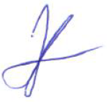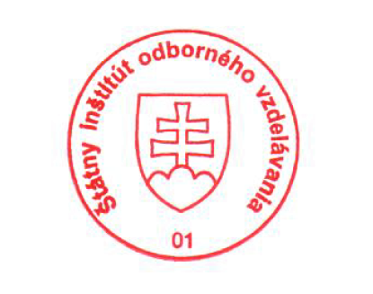 National Europass Centre
State Vocational Education Institute
Bellova 54/a,
837 63 Bratislava
europass@siov.sk
www.europass.sk

