1. Name of the Certificate ¹
Field of study 2435 H 01 tinsmith – engineering production
2. Translated title of the Certificate ²
Učebný odbor 2435 H 01 klampiar-strojárska výroba (sk)
3. Profile of skills and competences
The holder of the certificate is able:
- to act independently in social and professional life,
- to express themselves in the official language and one foreign language in written and spoken form,
- to apply the basic principles of financial literacy, consumer protection and to understand business and work,
- to use information and communication technologies to solve practical tasks,
- to work in diverse groups, to cooperate in a team, to organise their work,
- to act environmentally with a view to a sustainable development strategy,
- to apply the principles of occupational safety, health and environmental protection.
- to select and prepare the necessary tools, instruments, agents and work aids, devices, machines and equipment, material and raw materials necessary for a specific technological process and to use them efficiently,
- to carry out basic tasks during the manual working of metal,
- to machine and shape metal and non-metal materials on machinery,
- to use various types of mechanised tools and to choose optimal working conditions,
- to identify failures, to assess the effectiveness of product repair, to determine and implement repair method,
- to work in accordance with approved procedures, to comply with technical rules, technical and technological standards, including hygiene-related and safety and preventative measures,
- to assemble detachable component joints into simpler units and to fit the parts and observe the assembly order,
- to assemble non-detachable component joints into simpler units by welding, soldering, and glueing and to do simple fitting of the parts and observe the assembly order,
- to conduct checks of dimensions and shapes of products and to control the quality of completed work using suitable gauges and measurement devices,
- to construct atypical sheet metal parts without special production equipment and tools,
- to apply the principles of occupational cleanliness and hygiene at the workplace,
- to perform all essential tasks in the relevant field, to competently and rationally resolve simple problematic situations in professional activities.
4. Range of occupations accessible to the holder of the certificate ³
Graduates find work as tinsmiths in engineering and construction companies specialising in production, assembly, and repair of metalwork products.

5. Official basis of the certificate
Body awarding the certificate | Authority providing accreditation / recognition of the certificate
Ministry of Education, Science, Research and Sport of the Slovak Republic
Stromová 1
813 30 Bratislava
Phone: +421 2/59 374 111
www.minedu.sk
Level of the certificate (national or European) ¹  Secondary vocational education  SKQF/EQF 3  ISCED 353 | Grading scale / Pass requirements  1 – excellent  2 – praiseworthy  3 – good  4 – sufficient  5 – insufficient
Access to e next level of education / training 1  Advanced study educational programmes for graduates of the 3-year field of study  SKQF/EQF 4, ISCED 454 | International agreements on the recognition of qualifications ¹
Legal basis
Act No. 245/2008 Coll. on Education and Training (Education Act) and on amendment of certain acts; Act No. 61/2015 Coll. on Vocational Education and Training and on amendment of certain acts; Decree of the Ministry of Education of the Slovak Republic no. 318/2008 Coll. on the completion of studies at secondary schools, as amended.
6. Officially recognised ways of acquiring the certificate
Successful completion of the three-year training program in the given field of study by passing the final examination.
7. Additional information
This Europass Certificate Supplement is valid together with the school leaving certificate issued by the relevant secondary school (the name and address of the school is specified on the certificate). More details about the education and training system are available at www.minedu.sk/data/files/7421.jpg, more details as to the organisation of the educational system are available at www.minedu.sk, and the details of educational programs are available at www.siov.sk and at the website of the specified school.
Entry requirements ¹
- Completion of 9th year of primary school
- Demonstration of required knowledge prerequisites via admission procedure

More information (including a description of the national qualifications system)
Ministry of Education, Science, Research and Sport of the Slovak Republic, Study and Training Group
https://www.minedu.sk/18673-sk/studijne-a-ucebne-odbory-sauo/
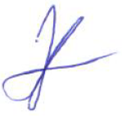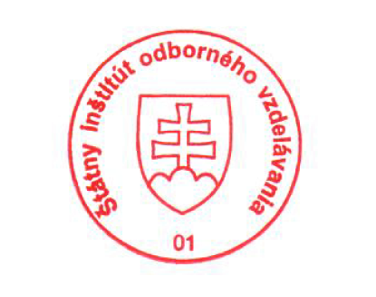 National Europass Centre
State Vocational Education Institute
Bellova 54/a,
837 63 Bratislava
europass@siov.sk
www.europass.sk

