1. Name of the Certificate ¹
Field of study 2413 K machinery and equipment mechanic
2. Translated title of the Certificate ²
Študijný odbor 2413 K mechanik strojov a zariadení (sk)
3. Profile of skills and competences
The holder of the certificate is able:
- to communicate correctly in the official language, both verbally and in writing,
- to communicate using one world language at the B1 level per the Common European Reference Framework,
- to adapt to changing living and working conditions, to work in a team and to take responsibility for tasks,
- to work with information, to use information and communication technologies and equipment,
- to apply the principles of financial literacy, consumer protection and to understand business and the work,
- to act environmentally with a view to a sustainable development strategy,
- to apply the principles of occupational health and safety and environmental protection,
- to create a technical image of machine parts and assemblies in engineering in accordance with standards,
- to carry out basic tasks in manual and machine working of plastic and metallic materials,
- to make practical use of engineering standards and technical documentation relating to machinery and equipment,
- to use appropriate tools, instruments, agents, and work aids,
- to make practical use of the fitting system and apply methods of component fitting using calculations and engineering data tables,
- to choose optimal working conditions, to comply with technical rules,
- to perform tests, inspections and diagnosis of machinery, mechanisms, and equipment,
- to apply measurements and inspection of accuracy and parameters of individual parts, products and components during assembly,
- to perform standard methods of pipe joining, insulation, and protection,
- to use technological and design documentation in the assembly operations,
- to perform inspection and maintenance of machinery and equipment in accordance with operating and service documentation,
- to classify technical status and malfunctions of machinery and equipment using service documentation,
- to create records of operation, maintenance and repair of machinery and equipment,
- to operate, set up and perform basic maintenance of machinery, mechanisms, and equipment,
- to connect electrical and logic circuits,
- to observe the safety standards for technical equipment when designing structural nodes.

4. Range of occupations accessible to the holder of the certificate ³
Graduates find work as laboratory technicians, supervisors, operations technicians, technical and economic workers in biochemical and pharmaceutical industry and related services, in research. Examples of possible job positions: laboratory technician – biochemist, machine operator in biochemical production, pharmaceutical laboratory technician in drug preparation technology, machine operator in pharmaceutical production.

5. Official basis of the certificate
Body awarding the certificate | Authority providing accreditation / recognition of the certificate
Ministry of Education, Science, Research and Sport of the Slovak Republic
Stromová 1
813 30 Bratislava
Phone: +421 2/59 374 111
www.minedu.sk
Level of the certificate (national or European) ¹  Full secondary vocational education  SKQF/EQF 4  ISCED 354 | Grading scale / Pass requirements  1 – excellent  2 – praiseworthy  3 – good  4 – sufficient  5 – insufficient
Access to e next level of education / training 1  Higher vocational education SKQF/EQF 5, ISCED 554  University, 1st degree, SKQF/EQF 6, ISCED 655, 645, 665  University, 2nd degree – continuous programs SKQF/EQF 7, ISCED 766 | International agreements on the recognition of qualifications ¹
Legal basis
Act No. 245/2008 Coll. on Education and Training (Education Act) and on amendment of certain acts; Act No. 61/2015 Coll. on Vocational Education and Training and on amendment of certain acts; Decree of the Ministry of Education of the Slovak Republic no. 318/2008 Coll. on the completion of studies at secondary schools, as amended.
6. Officially recognised ways of acquiring the certificate
Successful completion of the four-year training program in the given field of study by passing the final examination.
7. Additional information
This Europass Certificate Supplement is valid together with the school leaving certificate issued by the relevant secondary school (the name and address of the school is specified on the certificate). More details about the education and training system are available at www.minedu.sk/data/files/7421.jpg, more details as to the organisation of the educational system are available at www.minedu.sk, and the details of educational programs are available at www.siov.sk and at the website of the specified school.
Entry requirements ¹
- lower secondary education, ISCED 244
- fulfilment of prerequisites in the admission procedure
More information (including a description of the national qualifications system)
Ministry of Education, Science, Research and Sport of the Slovak Republic, Study and Training Group
https://www.minedu.sk/18673-sk/studijne-a-ucebne-odbory-sauo/
National Europass Centre
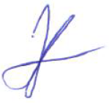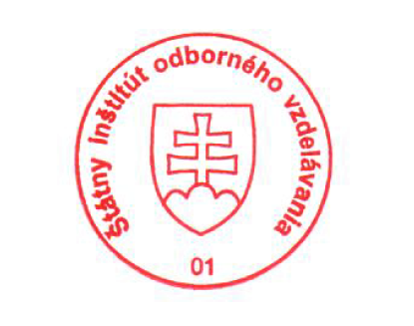State Vocational Education Institute
Bellova 54/a,
837 63 Bratislava
europass@siov.sk
www.europass.sk

