1. Name of the Certificate ¹
Field of study 2411 K mechanic adjuster
2. Translated title of the Certificate ²
Študijný odbor 2411 K mechanik nastavovač (sk)
3. Profile of skills and competences
The holder of the certificate is able:
- to communicate correctly in the official language, both verbally and in writing,
- to communicate using one world language at the B1 level per the Common European Reference Framework,
- to adapt to changing living and working conditions, to work in a team and to take responsibility for tasks,
- to work with information, to use information and communication technologies and equipment,
- to apply the principles of financial literacy, consumer protection and to understand business and the work,
- to act environmentally with a view to a sustainable development strategy,
- to apply the principles of occupational health and safety and environmental protection,
- to create a technical image of machine parts and assemblies in engineering in accordance with standards,
- to draw up technical documentation using CAD/CAM systems,
- to develop programmes and sub-programmes using CAM systems,
- to identify machine parts and characterise the operation of mechanisms used in mechanical engineering, to design simple assemblies,
- to understand technical documentation, standards and technical requirements related to the engineering production,
- to characterise basic types of semi-finished products in mechanical engineering, production process, and labelling,
- to design technological conditions, machinery, equipment and agents for basic types of machine part production,
- to characterise methods for determining the technical properties of materials,
- to determine appropriate gauges and measurement devices to perform a standard inspection of components and a measurement of technical properties,
- to comply with technical rules with regard to the use of cutting conditions and conservation of material and energy,
- to use software to operate NC and CNC machines,
- to set up NC and CNC machines according to the programme, to make tool corrections,
- to perform a final inspection of components after their manufacturing and to determine the means and methods of their measuring,
- to conduct simple maintenance on machinery and equipment.

4. Range of occupations accessible to the holder of the certificate ³
Graduates find work as CNC machine adjusters; they mount machines using tool holding fixtures and tools and they clamp material. Graduates set up machinery, test and debug programmes and machine settings. They replace worn or defective machine parts and make corrections in machine settings.

5. Official basis of the certificate
Body awarding the certificate | Authority providing accreditation / recognition of the certificate
Ministry of Education, Science, Research and Sport of the Slovak Republic
Stromová 1
813 30 Bratislava
Phone: +421 2/59 374 111
www.minedu.sk

Level of the certificate (national or European) ¹  Full secondary vocational education  SKQF/EQF 4  ISCED 354 | Grading scale / Pass requirements  1 – excellent  2 – praiseworthy  3 – good  4 – sufficient  5 – insufficient
Access to e next level of education / training 1  Higher vocational education SKQF/EQF 5, ISCED 554  University, 1st degree, ISCED 655, 645, 665 | International agreements on the recognition of qualifications ¹
Legal basis
Act No. 245/2008 Coll. on Education and Training (Education Act) and on amendment of certain acts; Act No. 61/2015 Coll. on Vocational Education and Training and on amendment of certain acts; Decree of the Ministry of Education of the Slovak Republic no. 318/2008 Coll. on the completion of studies at secondary schools, as amended.
6. Officially recognised ways of acquiring the certificate
Successful completion of the four-year training program in the given field of study by passing the final examination.
7. Additional information
This Europass Certificate Supplement is valid together with the school leaving certificate issued by the relevant secondary school (the name and address of the school is specified on the certificate). More details about the education and training system are available at www.minedu.sk/data/files/7421.jpg, more details as to the organisation of the educational system are available at www.minedu.sk, and the details of educational programs are available at www.siov.sk and at the website of the specified school.
Entry requirements ¹
- lower secondary education, ISCED 244
- fulfilment of prerequisites in the admission procedure

More information (including a description of the national qualifications system)
Ministry of Education, Science, Research and Sport of the Slovak Republic, Study and Training Group
https://www.minedu.sk/18673-sk/studijne-a-ucebne-odbory-sauo/

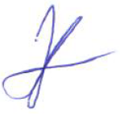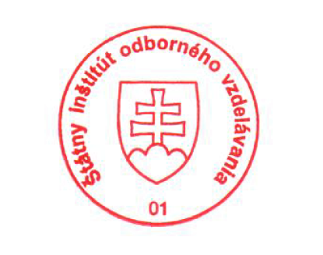 National Europass Centre
State Vocational Education Institute
Bellova 54/a,
837 63 Bratislava
europass@siov.sk
www.europass.sk

