1. Name of the Certificate ¹
Field of study 2426 K programmer of cutting and welding machinery and equipment
2. Translated title of the Certificate ²
Študijný odbor 2426 K programátor obrábacích a zváracích strojov a zariadení (sk)
3. Profile of skills and competences
The holder of the certificate is able:
- to communicate correctly in the official language, both verbally and in writing,
- to communicate using one world language at the B1 level per the Common European Reference Framework,
- to adapt to changing living and working conditions, to work in a team and to take responsibility for tasks,
- to work with information, to use information and communication technologies and equipment,
- to apply the principles of financial literacy, consumer protection and to understand business and the work,
- to act environmentally with a view to a sustainable development strategy,
- to apply the principles of occupational health and safety and environmental protection,
- to describe technical images of machine parts and assemblies in engineering in accordance with standards,
- to create images of machine parts and assemblies using CAD/CAM systems,
- to enter the control programme in the machine control system and make the necessary adjustments in terms of the geometric shape of the component and the technological conditions of machining,
- to propose technological conditions of machining, machines, tools and agents for cutting methods of production of machine components and to operate production machines,
- to use appropriate tools, instruments, agents, and work aids, to propose procedures for the production of machine components, mechanisms, and equipment,
- to use gauges and measurement devices to measure product dimensions and quality,
- to use engineering standards, technical literature, and fitting system and apply them at work,
- to develop programmes using software for controlling NC machines, to enter programmes for controlling NC machines and modify them appropriately,
- to choose work procedures in the production of components and in setting up production machines and lines,
- to weld with an open flame, an electric current and in a controlled atmosphere at the basic level,
- to use software to develop design technical and technological documentation.
4. Range of occupations accessible to the holder of the certificate ³
Graduates find work as technical professionals in the field of operation and programming of automated machinery. Graduates set up machinery, test and debug programmes and machine settings. They can also find work in the field of technological production preparation, design production preparation, production organisation and management. Examples of possible job positions: operator, dispatcher, technician, foreman, quality controller in the mechanical engineering industry.

5. Official basis of the certificate
Body awarding the certificate | Authority providing accreditation / recognition of the certificate
Ministry of Education, Science, Research and Sport of the Slovak Republic
Stromová 1
813 30 Bratislava
Phone: +421 2/59 374 111
www.minedu.sk
Level of the certificate (national or European) ¹  Full secondary vocational education  SKQF/EQF 4  ISCED 354 | Grading scale / Pass requirements  1 – excellent  2 – praiseworthy  3 – good  4 – sufficient  5 – insufficient
Access to e next level of education / training 1  Higher vocational education SKQF/EQF 5, ISCED 554  University, 1st degree, ISCED 655, 645, 665 | International agreements on the recognition of qualifications ¹
Legal basis
Act No. 245/2008 Coll. on Education and Training (Education Act) and on amendment of certain acts; Act No. 61/2015 Coll. on Vocational Education and Training and on amendment of certain acts; Decree of the Ministry of Education of the Slovak Republic no. 318/2008 Coll. on the completion of studies at secondary schools, as amended.
6. Officially recognised ways of acquiring the certificate
Successful completion of the four-year training program in the given field of study by passing the final examination.
7. Additional information
This Europass Certificate Supplement is valid together with the school leaving certificate issued by the relevant secondary school (the name and address of the school is specified on the certificate). More details about the education and training system are available at www.minedu.sk/data/files/7421.jpg, more details as to the organisation of the educational system are available at www.minedu.sk, and the details of educational programs are available at www.siov.sk and at the website of the specified school.
Entry requirements ¹
- lower secondary education, ISCED 244
- fulfilment of prerequisites in the admission procedure

More information (including a description of the national qualifications system)
Ministry of Education, Science, Research and Sport of the Slovak Republic, Study and Training Group
https://www.minedu.sk/18673-sk/studijne-a-ucebne-odbory-sauo/

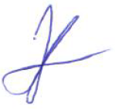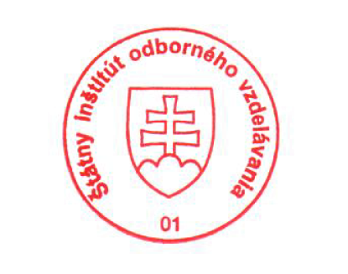 National Europass Centre
State Vocational Education Institute
Bellova 54/a,
837 63 Bratislava
europass@siov.sk
www.europass.sk

