1. Name of the Certificate ¹
Field of study 3758 K transport operation and economics operator
2. Translated title of the Certificate ²
Študijný odbor 3758 K operátor prevádzky a ekonomiky dopravy (sk)
3. Profile of skills and competences
The holder of the certificate is able:
- to communicate correctly in the official language, both verbally and in writing,
- to communicate using one world language at least at the B1 level per the Common European Reference Framework,
- to adapt to changing living and working conditions, to work in a team and to take responsibility for assigned tasks,
- to work with information, to use information and communication technologies and equipment,
- to apply basic mathematical relations and the laws of physics when resolving practical tasks,
- to apply the principles of financial literacy, consumer protection and to understand business and the world of work,
- to act environmentally with a view to a sustainable development strategy,
- to apply the principles of occupational health and safety and environmental protection,
- to define basic terms in the field of rail transport,
- to understand and locate information in basic standards and legislation in the field of rail transport, to implement technological practices,
- to properly give written orders, to use transport records, to keep train and transport documentation,
- to master the issues of the transport system and economic geography of selected countries,
- to master the construction, types, equipment, marking and use of individual rolling stock types and means of transport used in the combined transport system,
- to explain the principle of operation of telecommunications and safety installations in the field of transport,
- to operate individual telecommunications and safety installations in the field of transport.

4. Range of occupations accessible to the holder of the certificate ³
Graduates find work as qualified professionals able to carry out technical and operational work in the field of rail transport. They also find work as train dispatchers, controllers, operation supervisors, engineers, commanders, and rail traffic controllers.

5. Official basis of the certificate
Body awarding the certificate | Authority providing accreditation / recognition of the certificate
Ministry of Education, Science, Research and Sport of the Slovak Republic
Stromová 1
813 30 Bratislava
Phone: +421 2/59 374 111
www.minedu.sk
Level of the certificate (national or European) ¹  Full secondary vocational education  SKQF/EQF 4  ISCED 354 | Grading scale / Pass requirements  1 – excellent  2 – praiseworthy  3 – good  4 – sufficient  5 – insufficient
Access to e next level of education / training 1  Higher vocational education SKQF/EQF 5, ISCED 554  University, 1st degree, ISCED 655, 645, 665 | International agreements on the recognition of qualifications ¹
Legal basis
Act No. 245/2008 Coll. on Education and Training (Education Act) and on amendment of certain acts; Act No. 61/2015 Coll. on Vocational Education and Training and on amendment of certain acts; Decree of the Ministry of Education of the Slovak Republic no. 318/2008 Coll. on the completion of studies at secondary schools, as amended.
6. Officially recognised ways of acquiring the certificate
Successful completion of the four-year training program in the given field of study by passing the final examination.
7. Additional information
This Europass Certificate Supplement is valid together with the school leaving certificate issued by the relevant secondary school (the name and address of the school is specified on the certificate). More details about the education and training system are available at www.minedu.sk/data/files/7421.jpg, more details as to the organisation of the educational system are available at www.minedu.sk, and the details of educational programs are available at www.siov.sk and at the website of the specified school.
Entry requirements ¹
- lower secondary education, ISCED 244
- fulfilment of prerequisites in the admission procedure
More information (including a description of the national qualifications system)
Ministry of Education, Science, Research and Sport of the Slovak Republic, Study and Training Group
https://www.minedu.sk/18673-sk/studijne-a-ucebne-odbory-sauo/
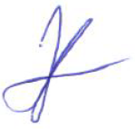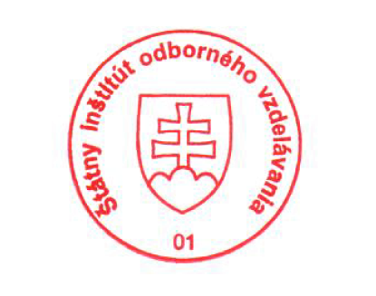 National Europass Centre
State Vocational Education Institute
Bellova 54/a,
837 63 Bratislava
europass@siov.sk
www.europass.sk

