1. Name of the Certificate ¹
Field of study 2956 H butcher, chef
2. Translated title of the Certificate ²
Učebný odbor 2956 H mäsiar kuchár (sk)
3. Profile of skills and competences
The holder of the certificate is able:
- ensure animal welfare,
- classify carcases according to EU standards,
- slaughter livestock, game and fish,
- separate, debone, portion meat and poultry,
- produce specified meat products, poultry products, cold kitchen products,
- determine the basic features of product quality, evaluate product errors and ways to eliminate them,
- master the basics of sensory and microbiological evaluation of products,
- aesthetically arrange products, conduct sales and services in the operation,
- maintain the conditions of storage and hygienic sales,
- implement the organization of work in the production, trade, sales and service centres,
- calculate the quantities of raw ingredients needed to prepare meals and calculate the prices of meals,
- to prepare hot and cold meals and to follow recipes,
- apply new trends in gastronomy and international cuisine,
- apply the principles of dietetics and prepare various diets,
- develop a menu and beverage card per gastronomical rules,
- select the correct work procedures, necessary ingredients and equipment to prepare meals,
- apply the principles of dining and related works for hot and cold buffets,
- to use the prescribed records: stock, production, dispatching and other records,
- properly manage waste in carcass processing, in meat production and gastronomy with regards to the environment,
- comply with the principles of good manufacturing practice, relevant standards and legislation including hygiene, safety, precautionary and fire protection measures, and measures for the protection of the environment,
- comply with the principles of personal and operational hygiene and psychohygiene.
4. Range of occupations accessible to the holder of the certificate ³
A graduate of the given field of study 2956 H butcher, chef can employ as a qualified worker in:
• industrial production, cooperatives and private enterprises, or as an independent entrepreneur in food production and various and various related services in the processing and sales of meat, meat products and delicatessen products,
• fields of catering, as well as a self-employed person.
The graduate can find work as a butcher, selling meat and meat products, or a chef in hotels, restaurants and other facilities.

5. Official basis of the certificate
Body awarding the certificate | Authority providing accreditation / recognition of the certificate
Ministry of Education, Science, Research and Sport of the Slovak Republic
Stromová 1
813 30 Bratislava
Phone: +421 2/59 374 111
www.minedu.sk

Level of the certificate (national or European) ¹  Secondary vocational education  SKQF/EQF: 3  ISCED 353 | Grading scale / Pass requirements  1 – excellent  2 – praiseworthy  3 – good  4 – sufficient  5 – insufficient
Access to the next level of education / training 1  Advanced study educational programmes for graduates of the 3-year field of study  SKQF/EQF 4, ISCED 454 | International agreements on the recognition of qualifications ¹
Legal basis
Act No. 245/2008 Coll. on Education and Training (Education Act) and on amendment of certain acts; Act No. 61/2015 Coll. on Vocational Education and Training and on amendment of certain acts; Decree of the Ministry of Education of the Slovak Republic no. 318/2008 Coll. on the completion of studies at secondary schools, as amended.
6. Officially recognised ways of acquiring the certificate
Successful completion of the four-year training program in the given field of study by passing the final examination.
7. Additional information
This Europass Certificate Supplement is valid together with the school leaving certificate issued by the relevant secondary school (the name and address of the school is specified on the certificate). More details about the education and training system are available at www.minedu.sk/data/files/7421.jpg, more details as to the organisation of the educational system are available at www.minedu.sk, and the details of educational programs are available at www.siov.sk and at the website of the specified school.
Entry requirements ¹
- lower secondary education, ISCED 244
- fulfilment of prerequisites in the admission procedure

More information (including a description of the national qualifications system)
Ministry of Education, Science, Research and Sport of the Slovak Republic, Study and Training Group
https://www.minedu.sk/18673-sk/studijne-a-ucebne-odbory-sauo/

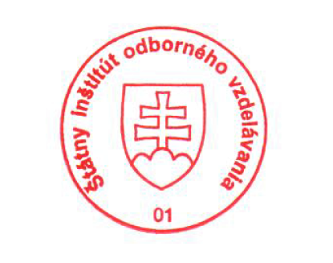 National Europass Centre
State Vocational Education Institute
Bellova 54/a,
837 63 Bratislava
europass@siov.sk
www.europass.sk

