1. Name of the Certificate ¹
Field of study 2950 M nutrition consultancy
2. Translated title of the Certificate ²
Študijný odbor 2950 M poradenstvo vo výžive (sk)
3. Profile of skills and competences
The holder of the certificate is able:
- apply theoretical knowledge in the field of human nutrition and health science to practical activities,
- apply the principles of counselling in practice,
- perform counselling diagnostics of the client,
- teach the client to overcome stress and use appropriate relaxation techniques,
- compile and control nutrition programs for clients of different ages with different health conditions, physical conditions, levels of performances and work and physical activities,
- propose suitable nutritional supplements in the nutrition program,
- compile exercise programs for various clients from various professions in compliance with the principles of a healthy lifestyle, follow up with them and adjust them individually,
- apply motion skills and abilities, manage motor activities at the required level while demonstrating the proposed physical activities in the exercise program,
- use modern ICT in composing nutrition and exercise programs,
- implement in practice various nutrition models according to the needs of the client,
- create and control conditions for the production of safe foods based on the principles of good manufacturing,
- perform sensory evaluation of food,
- perform microbiological and chemical analyses according to standards, correctly evaluate and explain the results of analyses,
- maintain the relevant health and safety principles, HACCP, ethical principles and standards,
- maintain the principles of hygiene and occupational safety, fire protection and environmental protection.

4. Range of occupations accessible to the holder of the certificate ³
The graduate can be employed in the field of nutrition counselling for compiling nutrition programs and compiling exercise programs, for counselling in the field of healthy lifestyles, in the food industry, gastronomy and catering, in educational, training and other organizations, in spas, relaxation, fitness centres and organizations.
Examples of possible job positions: nutrition consultant, nutrition therapist

5. Official framework of the certificate
Body awarding the certificate | Authority providing accreditation / recognition of the certificate
Ministry of Education, Science, Research and Sport of the Slovak Republic
Stromová 1
813 30 Bratislava
Phone: +421 2/59 374 111
www.minedu.sk
Level of the certificate (national or European) ¹  Full secondary vocational education  SKKR/EKR 4  ISCED 354 | Grading scale / Pass requirements  1 – excellent  2 – praiseworthy  3 – good  4 – sufficient  5 – insufficient
Access to the next level of education / training 1  University, 1st degree, ISCED 655, 645, 665  University, 2nd degree, ISCED 766, 767 | International agreements on the recognition of qualifications ¹
Legal basis
Act No. 245/2008 Coll. on Education and Training (Education Act) and on amendment of certain acts; Act No. 61/2015 Coll. on Vocational Education and Training and on amendment of certain acts; Decree of the Ministry of Education of the Slovak Republic no. 318/2008 Coll. on the completion of studies at secondary schools, as amended.
6. Officially recognised ways of acquiring the certificate
Successful completion of the four-year training program in the given field of study by passing the final examination.
7. Additional information
This Europass Certificate Supplement is valid together with the school leaving certificate issued by the relevant secondary school (the name and address of the school is specified on the certificate). More details about the education and training system are available at www.minedu.sk/data/files/7421.jpg, more details as to the organisation of the educational system are available at www.minedu.sk, and the details of educational programs are available at www.siov.sk and at the website of the specified school.
Entry requirements ¹
- lower secondary education, ISCED 244
- fulfilment of prerequisites in the admission procedure
More information (including a description of the national qualifications system)
Ministry of Education, Science, Research and Sport of the Slovak Republic, Study and Training Group
https://www.minedu.sk/18673-sk/studijne-a-ucebne-odbory-sauo/
National Europass Centre
State Vocational Education Institute
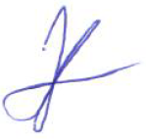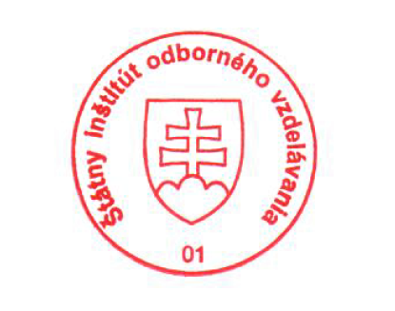Bellova 54/a,
837 63 Bratislava
europass@siov.sk
www.europass.sk

