1. Name of the Certificate ¹
Field of study 2846 Q process specialist for the chemical and pharmaceutical industry
2. Translation of the name of the certificate ²
Študijný odbor 2846 Q procesný špecialista pre chemický a farmaceutický priemysel (sk)
3. Profile of skills and competences
The holder of the certificate is able:
- communicate professionally in a foreign language,
- model and manage the processes of chemical and pharmaceutical technology and assess their economic parameters,
- implement process management of a specific technological process,
- apply skills in the field of control systems, regulation, measurement, remote measurement and information transmission, electrical engineering and programming,
- evaluate and adjust the work schedule / plan based on the current state of the company and specific needs (with regard to optimization processes, work safety, guidelines and quality of production),
- apply logistics systems in individual areas of the chemical and pharmaceutical industry in the field of management of industrial production, transport, supply, distribution, services, purchasing, warehousing operations,
- apply the quality control management system, design, control and update the managed documentation of the company,
- design the basics of production planning (including process optimization, occupational safety, quality management and GMP),
- work with safety data sheets and implement the REACH regulations,
- observe the principles of safety at work and occupational hygiene,
- apply the principles of environmental protection.
4. Range of occupations accessible to the holder of the certificate ³
The graduate can be employed in professions and job positions of process specialists in the chemical and pharmaceutical industries, as well as in fields of environment and applied chemistry.
Examples of possible job positions: executive senior higher qualified and middle qualified management official responsible for production equipment, logistics of raw materials, semi-finished products, intermediate products and final products, management of reaction processes and cleaning procedures for the final product, equipment maintenance planning, chemical substances formulation - proper procedures and management of the preparation of mixtures, preparation of technical and operational documentation, implementation of operational experiments, testing and verification of new products and technologies.

5. Official basis of the certificate
Body awarding the certificate | Authority providing accreditation / recognition of the certificate
Ministry of Education, Science, Research and Sport of the Slovak Republic
Stromová 1
813 30 Bratislava
Phone: +421 2/59 374 111
www.minedu.sk
Level of the certificate (national or European) ¹  Higher vocational education  SKKR/EKR 5  ISCED 554 | Grading scale / Pass requirements  1 – excellent  2 – praiseworthy  3 – good  4 – sufficient  5 – insufficient
Access to the next level of education / training 1  University, 1st degree, SKQF/EQF 6, ISCED 655, 645, 665  University, 2nd degree, SKKR/EKR 7, ISCED 766, 767 | International agreements on the recognition of qualifications ¹
Legal basis
Act No. 245/2008 Coll. on Education and Training (Education Act) and on amendment of certain acts; Act No. 61/2015 Coll. on Vocational Education and Training and on amendment of certain acts; Decree of the Ministry of Education of the Slovak Republic no. 318/2008 Coll. on the completion of studies at secondary schools, as amended.
6. Official recognition of means of attaining the certificate
Successful completion of the four-year training program in the given field of study by passing the final examination.
7. Officially recognised ways of acquiring the certificate
This Europass Certificate Supplement is valid together with the school leaving certificate issued by the relevant secondary school (the name and address of the school is specified on the certificate). More details about the education and training system are available at www.minedu.sk/data/files/7421.jpg, more details as to the organisation of the educational system are available at www.minedu.sk, and the details of educational programs are available at www.siov.sk and at the website of the specified school.
Entry requirements ¹
- Completed secondary vocational education in the given field of study, ISCED 354
- fulfilment of prerequisites in the admission procedure
More information (including a description of the national qualifications system)
Ministry of Education, Science, Research and Sport of the Slovak Republic, Study and Training Group
https://www.minedu.sk/18673-sk/studijne-a-ucebne-odbory-sauo/
National Europass Centre
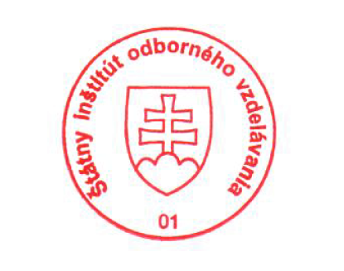State Vocational Education Institute
Bellova 54/a,
837 63 Bratislava
europass@siov.sk
www.europass.sk

