1. Name of the Certificate ¹
Field of study 2955 H butcher, worker in delicatessen
2. Translated title of the Certificate ²
Učebný odbor 2955 H mäsiar, lahôdkar (sk)
3. Profile of skills and competences
The holder of the certificate is able:
- to act independently in social and professional life,
- to express themselves in the official language and one foreign language in written and spoken form,
- to apply the basic principles of financial literacy, consumer protection and to understand business and work,
- to use information and communication technologies to solve practical tasks,
- to work in diverse groups, to cooperate in a team, to organise their work,
- to act environmentally with a view to a sustainable development strategy,
- to accept, assess the quality and store the materials for the production of meat products, to prepare the materials for cutting and production of various types of meat products,
- to prepare the necessary materials, tools, instruments, machines and devices for a specific technological process and to use them efficiently,
- to explain standards applicable to the production and inspection of meat products,
- to explain the technological procedures for the preparation of delicatessen and cold kitchen products,
- to prepare ingredients for the production of various cold kitchen products,
- to produce delicatessen products, canned food and semi-canned food,
- to set up, continuously maintain the relevant machines, to set up and operate machines and equipment, to perform their basic maintenance and to produce the specified meat products,
- to operatively adjust the technological regime or recipe,
- to apply modern trends in technological processes in production,
- to use the prescribed records: stock, production, dispatching and other records,
- to prepare meat for sale, apply basic packaging techniques and the principles of proper storage,
- to apply basic arrangement works and sales principles, communicate with customers,
- to carry out all hygienic and sanitary measures at the workplace,
- to comply with the principles of good manufacturing practice, relevant standards and legislation including hygiene, safety and precautionary measures, and HACCP regulations.
4. Range of occupations accessible to the holder of the certificate ³
Graduates find work as butchers and workers in delicatessen employed in small, medium and large establishments and in the sale of products. After obtaining experience, they are ready to establish a private business.

5. Official basis of the certificate
Body awarding the certificate | Authority providing accreditation / recognition of the certificate
Ministry of Education, Science, Research and Sport of the Slovak Republic
Stromová 1
813 30 Bratislava
Phone: +421 2/59 374 111
www.minedu.sk
Level of the certificate (national or European) ¹  Secondary vocational education  SKQF/EQF: 3  ISCED 353 | Grading scale / Pass requirements  1 – excellent  2 – praiseworthy  3 – good  4 – sufficient  5 – insufficient
Access to next level of education / training 1  Advanced study educational programmes for graduates of the 3-year and 4-year field of study  SKQF/EQF 4, ISCED 454 | International agreements on the recognition of qualifications ¹
Legal basis
Act No. 245/2008 Coll. on Education and Training (Education Act) and on amendment of certain acts; Act No. 61/2015 Coll. on Vocational Education and Training and on amendment of certain acts; Decree of the Ministry of Education of the Slovak Republic no. 318/2008 Coll. on the completion of studies at secondary schools, as amended.
6. Officially recognised ways of acquiring the certificate
Successful completion of the four-year training program in the given field of study by passing the final examination.
7. Additional information
This Europass Certificate Supplement is valid together with the school leaving certificate issued by the relevant secondary school (the name and address of the school is specified on the certificate). In addition to the school leaving certificate, the school issues also the certificates of apprenticeship. More details about the education and training system are available at www.minedu.sk/data/files/7421.jpg, more details as to the organisation of the educational system are available at www.minedu.sk, and the details of educational programs are available at www.siov.sk and at the website of the specified school.
Entry requirements ¹
- Completion of 9th year of primary school
- Demonstration of required knowledge prerequisites via admission procedure
More information (including a description of the national qualifications system)
Ministry of Education, Science, Research and Sport of the Slovak Republic, Study and Training Group
https://www.minedu.sk/18673-sk/studijne-a-ucebne-odbory-sauo/
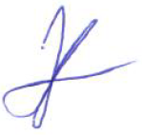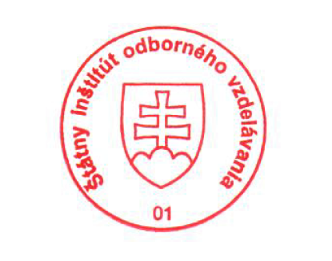 National Europass Centre
State Vocational Education Institute
Bellova 54/a,
837 63 Bratislava
europass@siov.sk
www.europass.sk

