1. Name of the Certificate ¹
Field of study 2952 L food production
2. Translated title of the Certificate ²
Študijný odbor 2952 L výroba potravín (sk)
3. Profile of skills and competences
The holder of the certificate is able:
- to communicate correctly in the official language, both verbally and in writing,
- to communicate using one world language at least at the B1 level per the Common European Reference Framework,
- to adapt to changing living and working conditions, to work in a team and to take responsibility for assigned tasks,
- to work with information, to use information and communication technologies and equipment,
- to apply basic mathematical relations and the laws of physics and chemistry when resolving practical tasks,
- to apply the principles of financial literacy, consumer protection and to understand business and the world of work,
- to act environmentally with a view to a sustainable development strategy, assess the impact of the technological process on the environment, to eliminate negative impacts,
- to design and organise the production processes, to control and manage the technological process,
- to sort products according to their quality, to determine the price quote for the product,
- to read technical and technological documentation,
- to set and operate machines, instruments and some technological equipment in production according to the instructions,
- to work with appropriate raw materials, materials, aids, tools and machines,
- to use basic methods of food analysis,
- to identify product errors, analyse their causes, draw conclusions, ensure elimination of their errors,
- to apply the principles of occupational hygiene, health and safety principles, ecological aspects of individual productions, to adhere to HACCP.

4. Range of occupations accessible to the holder of the certificate ³
Graduates find work as qualified professionals in food production and related services or in establishments and laboratories as: foremen, laboratory technicians, technical and economic workers in food industry and in distribution and sale of food.

5. Official basis of the certificate
Body awarding the certificate | Authority providing accreditation / recognition of the certificate
Ministry of Education, Science, Research and Sport of the Slovak Republic
Stromová 1
813 30 Bratislava
Phone: +421 2/59 374 111
www.minedu.sk
Level of the certificate (national or European) ¹  Full secondary vocational education  SKQF/EQF 4  ISCED 454 | Grading scale / Pass requirements  1 – excellent  2 – praiseworthy  3 – good  4 – sufficient  5 – insufficient
Access to next level of education / training 1  Higher vocational education SKQF/EQF 5, ISCED 554  University, 1st degree, SKQF/EQF 6, ISCED 655, 645, 665  University, 2nd degree – SKQF/EQF 7, ISCED 766 | International agreements on the recognition of qualifications ¹
Legal basis
Act No. 245/2008 Coll. on Education and Training (Education Act) and on amendment of certain acts; Act No. 61/2015 Coll. on Vocational Education and Training and on amendment of certain acts; Decree of the Ministry of Education of the Slovak Republic no. 318/2008 Coll. on the completion of studies at secondary schools, as amended.
6. Officially recognised ways of acquiring the certificate
Successful completion of the four-year training program in the given field of study by passing the final examination.
7. Additional information
This Europass Certificate Supplement is valid together with the school leaving certificate issued by the relevant secondary school (the name and address of the school is specified on the certificate). More details about the education and training system are available at www.minedu.sk/data/files/7421.jpg, more details as to the organisation of the educational system are available at www.minedu.sk, and the details of educational programs are available at www.siov.sk and at the website of the specified school.
Entry requirements ¹
- secondary vocational education in the given field of study, ISCED 353
- Fulfilment of prerequisites in the admission procedure
More information (including a description of the national qualifications system)
Ministry of Education, Science, Research and Sport of the Slovak Republic, Study and Training Group
https://www.minedu.sk/18673-sk/studijne-a-ucebne-odbory-sauo/
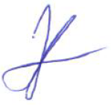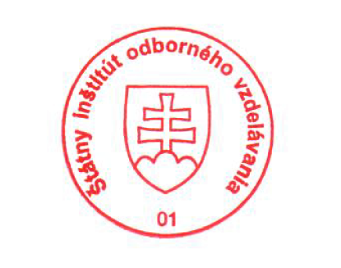 National Europass Centre
State Vocational Education Institute
Bellova 54/a,
837 63 Bratislava
europass@siov.sk
www.europass.sk

