1. Name of the Certificate ¹
Field of study 2877 H chemist for the maintenance of textile product and other services
2. Translated title of the Certificate ²
Učebný odbor 2877 H chemik pre udržiavanie textilných výrobkov a ďalšie služby (sk)
3. Profile of skills and competences
The holder of the certificate is able:
- to act independently in social and professional life,
- to express themselves in the official language and one foreign language in written and spoken form,
- to apply the basic principles of financial literacy, consumer protection and to understand business and the world of work,
- to use information and communication technologies to solve practical tasks,
- to work in diverse groups, to cooperate in a team, to organise their work,
- to act environmentally with a view to a sustainable development strategy,
- to take over upon delivery, mark, sort, store and dispatch orders,
- to implement technological procedures of washing, dry cleaning, dyeing and removing stains from fabrics and clothing,
- to identify and remove stains and dirt from textile and other materials,
- to dye fabrics,
- to carry out works in tannery establishments,
- to initiate contact with customers and adhere to the principles of social behaviour,
- to provide professional consulting services, apply the principles of supply and quality sales of textile and other materials and cleaning products,
- to perform works in handling, storage and sale of goods (textile and other materials, washing and auxiliary detergents, cleaning products),
- to observe the principles of occupational health and safety, occupational hygiene and safety regulations, nature protection and to act in accordance therewith.

4. Range of occupations accessible to the holder of the certificate ³
Graduates find work in all establishments dealing with the collection, sorting, washing and cleaning of laundry and clothing, in dying establishments of textile and other materials and in tanning industry. Graduates are ready for the sale of textile and other materials, washing and auxiliary detergents, cleaning products and related services, as well as for conducting a private business.

5. Official basis of the certificate
Body awarding the certificate | Authority providing accreditation / recognition of the certificate
Ministry of Education, Science, Research and Sport of the Slovak Republic
Stromová 1
813 30 Bratislava
Phone: +421 2/59 374 111
www.minedu.sk
Level of the certificate (national or European)¹  Secondary vocational education  SKQF/EQF: 3  ISCED 353 | Grading scale / Pass requirements  1 – excellent  2 – praiseworthy  3 – good  4 – sufficient  5 – insufficient
Access to next level of education / training 1  Advanced study educational programmes for graduates of the 3-year and 4-year field of study  SKQF/EQF 4, ISCED 454 | International agreements on the recognition of qualifications ¹
Legal basis
Act No. 245/2008 Coll. on Education and Training (Education Act) and on amendment of certain acts; Act No. 61/2015 Coll. on Vocational Education and Training and on amendment of certain acts; Decree of the Ministry of Education of the Slovak Republic no. 318/2008 Coll. on the completion of studies at secondary schools, as amended.
6. Officially recognised ways of acquiring the certificate
Successful completion of the four-year training program in the given field of study by passing the final examination.
7. Additional information
This Europass Certificate Supplement is valid together with the school leaving certificate issued by the relevant secondary school (the name and address of the school is specified on the certificate). In addition to the school leaving certificate, the school issues also the certificates of apprenticeship. More details about the education and training system are available at www.minedu.sk/data/files/7421.jpg, more details as to the organisation of the educational system are available at www.minedu.sk, and the details of educational programs are available at www.siov.sk and at the website of the specified school.
Entry requirements ¹
- Completion of 9th year of primary school
- Demonstration of required knowledge prerequisites via admission procedure
More information (including a description of the national qualifications system)
Ministry of Education, Science, Research and Sport of the Slovak Republic, Study and Training Group
https://www.minedu.sk/18673-sk/studijne-a-ucebne-odbory-sauo/
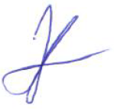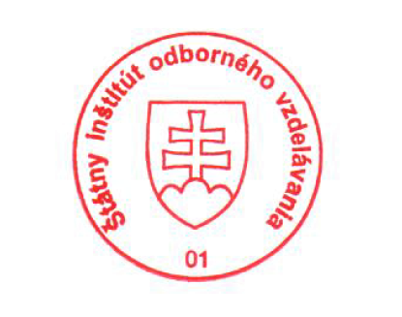 National Europass Centre
State Vocational Education Institute
Bellova 54/a,
837 63 Bratislava
europass@siov.sk
www.europass.sk

