1. Name of the Certificate ¹
Field of study 2978 H confectioner – baker
2. Translated title of the Certificate ²
Učebný odbor 2978 H cukrár, pekár (sk)
3. Profile of skills and competences
The holder of the certificate is able:
- to act independently in social and professional life,
- to express themselves in the official language and one foreign language in written and spoken form,
- to apply the basic principles of financial literacy, consumer protection and to understand business and the work,
- to use information and communication technologies to solve practical tasks,
- to work in diverse groups, to cooperate in a team, to organise their work,
- to act environmentally with a view to a sustainable development strategy,
- to apply the principles of occupational health and safety and environmental protection,
- to receive, assess the quality and store raw materials for the production of confectionery and bakery products, to prepare material, tools, instruments, machines and devices necessary for a specific technological process and use them economically,
- to work according to standards and procedures in the production of confectionery and bakery products,
- to comply with the principles of good manufacturing practice, relevant standards and legislation including hygiene, safety and precautionary measures,
- To make confectionery and bakery semi-finished products, bases, finished products, ice cream and pastries, bread and other bakery products according to the technological process and to complete them artistically and aesthetically,
- to assess their quality and carry out quality control at each stage of production,
- to store, pack, dispatch and sell products,
- to control individual stages of the production process and to carry out all hygienic and sanitary measures,
- to set up and operate machines and equipment, perform their basic maintenance,
- to use the prescribed records: stock, production, dispatching and other records,
- to use and to understand progressive methods and raw materials,
- to check for compliance with standards applicable to the production of meals, the methods and forms of handling meals, foodstuffs and their continued storage and the storage of ingredients, to apply HACCP regulations.
4. Range of occupations accessible to the holder of the certificate ³
Graduates find work in two professions – confectioner and baker employed in small, medium and large confectioneries and bakeries and in the sale of confectionery and bakery products. After obtaining experience, they are ready to establish a private business.

5. Official basis of the certificate
Body awarding the certificate | Authority providing accreditation / recognition of the certificate
Ministry of Education, Science, Research and Sport of the Slovak Republic
Stromová 1
813 30 Bratislava
Phone: +421 2/59 374 111
www.minedu.sk
Level of the certificate (national or European) ¹  Secondary vocational education  SKQF/EQF: 3  ISCED 353 | Grading scale / Pass requirements  1 – excellent  2 – praiseworthy  3 – good  4 – sufficient  5 – insufficient
Access to next level of education / training 1  Advanced study educational programmes for graduates of the 3-year and 4-year field of study  SKQF/EQF 4, ISCED 454 | International agreements on the recognition of qualifications ¹
Legal basis
Act No. 245/2008 Coll. on Education and Training (Education Act) and on amendment of certain acts; Act No. 61/2015 Coll. on Vocational Education and Training and on amendment of certain acts; Decree of the Ministry of Education of the Slovak Republic no. 318/2008 Coll. on the completion of studies at secondary schools, as amended.
6. Officially recognised ways of acquiring the certificate
Successful completion of the four-year training program in the given field of study by passing the final examination.
7. Additional information
This Europass Certificate Supplement is valid together with the school leaving certificate issued by the relevant secondary school (the name and address of the school is specified on the certificate). In addition to the school leaving certificate, the school issues also the certificates of apprenticeship. More details about the education and training system are available at www.minedu.sk/data/files/7421.jpg, more details as to the organisation of the educational system are available at www.minedu.sk, and the details of educational programs are available at www.siov.sk and at the website of the specified school.
Entry requirements ¹
- Completion of 9th year of primary school
- Demonstration of required knowledge prerequisites via admission procedure
More information (including a description of the national qualifications system)
Ministry of Education, Science, Research and Sport of the Slovak Republic, Study and Training Group
https://www.minedu.sk/18673-sk/studijne-a-ucebne-odbory-sauo/
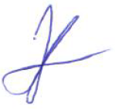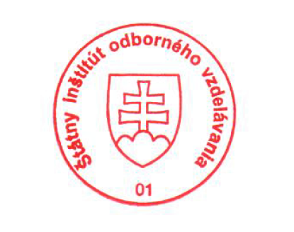 National Europass Centre
State Vocational Education Institute
Bellova 54/a,
837 63 Bratislava
europass@siov.sk
www.europass.sk

