1. Name of the Certificate ¹
Field of study 2675 L 02 electrical engineering – production and operation of machinery and equipment
2. Translated title of the Certificate ²
Študijný odbor 2675 L 02 elektrotechnika – výroba a prevádzka strojov a zariadení (sk)
3. Profile of skills and competences
The holder of the certificate is able to:
- to communicate correctly in the official language, both verbally and in writing,
- to communicate using one world language at least at the B1 level per the Common European Reference Framework,
- to adapt to changing living and working conditions, to work in a team and to take responsibility for assigned tasks,
- to work with information, to use information and communication technologies and equipment,
- to apply basic mathematical relations and the laws of physics and chemistry when resolving practical tasks,
- to apply the principles of financial literacy, consumer protection and to understand business and the world of work,
- to act environmentally with regard to a sustainable development strategy,
- to apply the principles of occupational health and safety and environmental protection,
- to read and draw technical drawings, diagrams, work tutorials, to understand technical documentation, standards, regulations and to keep operational-technical documentation,
- to select optimal technical process for production, installation, maintenance, set-up, inspection of electrical engineering equipment,
- to design, construct, test and operate electrical machinery, instruments and equipment,
- to construct, assemble, install and refurbish electrical machines, instruments, appliances and equipment in real operational conditions,
- to operate electrical machinery and equipment functionally and effectively, to set-up operational parameters, electrical engineering or electronic equipment and ensure basic maintenance and optimal mode of operation in accordance with technical and operational conditions,
- to apply principles and means of designing electrical installations of residential and industrial buildings,
- to use measuring instruments to measure parameters and characteristics of electrical machinery and instruments, to use measured values for control and diagnosis of equipment, to repair electrical machines and electrical equipment based on the diagnosed values.
4. Range of occupations accessible to the holder of the certificate ³
Graduates find work as qualified workers able to independently perform works related to production, installation, operation, repair, set-up and testing of electrical machines, instruments and equipment and in selected technical-economic activities of operational character in management of production, control, service, repair and retail operation focused of electrical engineering.
Examples of potential job titles include: mechanic, repairer of electrical engineering equipment, constructor of electrical equipment and systems, operating technician of electricity maintenance, installer in electrical engineering production, foreman (supervisor) in electrical engineering production, electrical engineering systems sales professional, technical inspection and diagnosis technician in electrical engineering and energy sector, electro technician, quality inspector, electrical engineering equipment test engineer.

5. Official basis of the certificate
Body awarding the certificate | Authority providing accreditation / recognition of the certificate
Ministry of Education, Science, Research and Sport of the Slovak Republic
Stromová 1
813 30 Bratislava
Phone: +421 2/59 374 111
www.minedu.sk
Level of the certificate (national or European) ¹  Full secondary vocational education  SKEQ/EQF 4  ISCED 454 | Grading scale / Pass requirements  1 – excellent  2 – praiseworthy  3 – good  4 – sufficient  5 – insufficient
Access to next level of education / training ¹  Higher vocational education SKQF/EQF 5, ISCED 554  University, 1st degree, ISCED 655, 645, 665 | International agreements on recognition of qualifications¹
Legal basis
Act No. 245/2008 Coll. on Education and Training (Education Act) and on amendment of certain acts; Act No. 61/2015 Coll. on Vocational Education and Training and on amendment of certain acts; Decree of the Ministry of Education of the Slovak Republic no. 318/2008 Coll. on the completion of studies at secondary schools, as amended.
6. Officially recognised ways of acquiring the certificate
Successful completion of the four-year training program in the given field of study by passing the school leaving examination.
7. Additional information
This Europass Certificate Supplement is valid together with the school leaving certificate issued by the relevant secondary school (the name and address of the school is specified on the certificate). More details about the education and training system are available at www.minedu.sk/data/files/7421.jpg, more details as to the organisation of the educational system are available at www.minedu.sk, and the details of educational programs are available at www.siov.sk and at the website of the specified school.
Entry requirements ¹
- secondary vocational education in the given field of study, ISCED 353
- fulfilment of prerequisites in the admission procedure
More information (including a description of the national qualifications system)
Ministry of Education, Science, Research and Sport of the Slovak Republic, Study and Training Group
https://www.minedu.sk/18673-sk/studijne-a-ucebne-odbory-sauo/
National Europass Centre
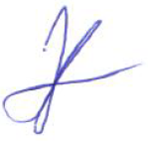
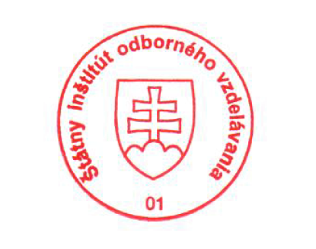
State Vocational Education Institute
Bellova 54/a,
837 63 Bratislava
europass@siov.sk
www.europass.sk

