1. Name of the Certificate ¹
Field of study 2675 L 01 electrical engineering – energetics
2. Translated title of the Certificate ²
Študijný odbor 2675 L 01 elektrotechnika – energetika (sk)
3. Profile of skills and competences
The holder of the certificate is able to:
- to communicate correctly in the official language, both verbally and in writing,
- to communicate using one world language at least at the B1 level per the Common European Reference Framework,
- to adapt to changing living and working conditions, to work in a team and to take responsibility for assigned tasks,
- to work with information, to use information and communication technologies and equipment,
- to apply basic mathematical relations and the laws of physics and chemistry when resolving practical tasks,
- to apply the principles of financial literacy, consumer protection and to understand business and the world of work,
- to act environmentally with regard to a sustainable development strategy,
- to apply the principles of occupational health and safety and environmental protection,
- to read and draw technical drawings, diagrams, work tutorials, to understand technical documentation, standards, regulations and to keep operational-technical documentation of energy equipment,
- to select the correct technical process for production, installation, maintenance, set-up, technical parameters of electrical and electronic equipment in energy sector,
- to perform installation, maintenance and repair of electrical lines, energy equipment, electrical installation and electrical circuits,
- to design, construct, test and operate electrical machinery, instruments and equipment,
- to functionally and effectively operate energy machinery and equipment, to set-up operational parameters, electrical engineering or electronic equipment and ensure basic maintenance and optimal mode of operation in accordance with technical and operational conditions,
- to understand the issues of electrical networks, circuits, energy equipment and plants producing electricity in the lighting systems and thermal installations sector,
- to use measuring instruments to measure electrical quantities and parameters of measuring and regulating equipment, characteristics of electrical machinery and instruments, to use measured values for the control of the operation of energy distribution equipment and equipment for the transmission and distribution of electricity.
4. Range of occupations accessible to the holder of the certificate ³
Graduates find work as middle technical-economic specialists in the electrical engineering and energy sector, in construction, technological and design professional activities. They can manage operation in electrical engineering and energy companies, manage supplying, perform revision and refurbish electrical equipment.
Examples of potential job titles include: energy technician, designer and constructor, foreman energy technician, revision technician, dispatcher of transmission and distribution of electricity, electricity installer of electro energetic security, technical inspection and diagnosis technician in electrical engineering and energy sector, electrical engineering systems sales professional, quality controller electro technician, test engineer of electrical engineering equipment.

5. Official basis of the certificate
Body awarding the certificate | Authority providing accreditation / recognition of the certificate
Ministry of Education, Science, Research and Sport of the Slovak Republic
Stromová 1
813 30 Bratislava
Phone: +421 2/59 374 111
www.minedu.sk
Level of the certificate (national or European) ¹  Full secondary vocational education  SKEQ/EQF 4  ISCED 454 | Grading scale / Pass requirements  1 – excellent  2 – praiseworthy  3 – good  4 – sufficient  5 – insufficient
Access to next level of education / training ¹  Higher vocational education SKQF/EQF 5, ISCED 554  University, 1st degree, ISCED 655, 645, 665 | International agreements on recognition of qualifications¹
Legal basis
Act No. 245/2008 Coll. on Education and Training (Education Act) and on amendment of certain acts; Act No. 61/2015 Coll. on Vocational Education and Training and on amendment of certain acts; Decree of the Ministry of Education of the Slovak Republic no. 318/2008 Coll. on the completion of studies at secondary schools, as amended.
6. Officially recognised ways of acquiring the certificate
Successful completion of the four-year training program in the given field of study by passing the school leaving examination.
7. Additional information
This Europass Certificate Supplement is valid together with the school leaving certificate issued by the relevant secondary school (the name and address of the school is specified on the certificate). More details about the education and training system are available at www.minedu.sk/data/files/7421.jpg, more details as to the organisation of the educational system are available at www.minedu.sk, and the details of educational programs are available at www.siov.sk and at the website of the specified school.
Entry requirements ¹
- secondary vocational education in the given field of study, ISCED 353
- fulfilment of prerequisites in the admission procedure
More information (including a description of the national qualifications system)
Ministry of Education, Science, Research and Sport of the Slovak Republic, Study and Training Group
https://www.minedu.sk/18673-sk/studijne-a-ucebne-odbory-sauo/
National Europass Centre
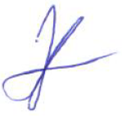
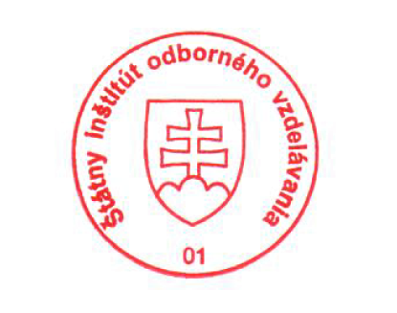
State Vocational Education Institute
Bellova 54/a,
837 63 Bratislava
europass@siov.sk
www.europass.sk

