1. Name of the Certificate ¹
Field of study 2682 K computer network mechanic
2. Translated title of the Certificate ²
Študijný odbor 2682 K mechanik počítačových sietí (sk)
3. Profile of skills and competences
The holder of the certificate is able to:
- to communicate correctly in the official language, both verbally and in writing,
- to communicate using one world language at least at the B1 level per the Common European Reference Framework,
- to adapt to changing living and working conditions, to work in a team and to take responsibility for assigned tasks,
- to work with information, to use information and communication technologies and equipment,
- to apply basic mathematical relations and the laws of physics and chemistry when resolving practical tasks,
- to apply the principles of financial literacy, consumer protection and to understand business and the world of work,
- to act environmentally with regard to a sustainable development strategy,
- to apply the principles of occupational health and safety and environmental protection,
- to read technical drawings, diagrams, work tutorials, to understand technical documentation, standards, regulations and to keep technical documentation of the operation, maintenance and repairs of computer networks,
- to design material and determine processes of computer network assembly,
- to understand standard software and hardware equipment and work with usual peripheral equipment,
- to create and design the structure of computer network and establish data network,
- to install, configure and manage computer networks and connect PC to network,
- to master the basics of testing and diagnosis of computer systems, monitor the operation, diagnose faults and perform repairs of computer networks,
- to install, configure and perform service of PC components, peripheral equipment and communication means and means for data transmission (modem, memory media) connected to computers,
- to install, configure operation systems and application software,
- to select and implement system of securing data against misuse and protection of data against destruction.
4. Range of occupations accessible to the holder of the certificate ³
Graduates find work in the field of the design, implementation and management of computer networks and systems.
Examples of potential job titles include: computer networks and systems technician, computer networks mechanic

5. Official basis of the certificate
Body awarding the certificate | Authority providing accreditation / recognition of the certificate
Ministry of Education, Science, Research and Sport of the Slovak Republic
Stromová 1
813 30 Bratislava
Phone: +421 2/59 374 111
www.minedu.sk
Level of the certificate (national or European) ¹  Full secondary vocational education  SKQF/EQF 4  ISCED 354 | Grading scale / Pass requirements  1 – excellent  2 – praiseworthy  3 – good  4 – sufficient  5 – insufficient
Access to next level of education / training ¹  Higher vocational education SKQF/EQF 5, ISCED 554  University, 1st degree, ISCED 655, 645, 665 | International agreements on recognition of qualifications¹
Legal basis
Act No. 245/2008 Coll. on Education and Training (Education Act) and on amendment of certain acts; Act No. 61/2015 Coll. on Vocational Education and Training and on amendment of certain acts; Decree of the Ministry of Education of the Slovak Republic no. 318/2008 Coll. on the completion of studies at secondary schools, as amended.
6. Officially recognised ways of acquiring the certificate
Successful completion of the four-year training program in the given field of study by passing the school leaving examination.
7. Additional information
This Europass Certificate Supplement is valid together with the school leaving examination certificate issued by the relevant secondary school (the name and address of the school is specified on the certificate). More details about the education and training system are available at www.minedu.sk/data/files/7421.jpg, more details as to the organisation of the educational system are available at www.minedu.sk, and the details of educational programs are available at www.siov.sk and at the website of the specified school.
Entry requirements ¹
- lower secondary education ISCED 244
- fulfilment of prerequisites in the admission procedure
More information (including a description of the national qualifications system)
Ministry of Education, Science, Research and Sport of the Slovak Republic, Study and Training Group
https://www.minedu.sk/18673-sk/studijne-a-ucebne-odbory-sauo/
National Europass Centre
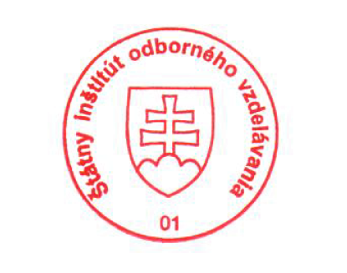
State Vocational Education Institute
Bellova 54/a,
837 63 Bratislava
europass@siov.sk
www.europass.sk

