1. Name of the Certificate ¹
Field of study 6851 Q social legal activity (higher vocational education)
2. Translated title of the Certificate ²
Field of study 6851 Q social legal activity (higher vocational education) (sk)
3. Profile of skills and competences
The holder of the certificate is able to:
- to communicate using at least one world language at the B1 level per the Common European Reference Framework, to apply vocabulary in the scope of the determined specialized topics,
- to work independently and creatively, to be involved in teamwork,
- to plan, organise, carry out and evaluate particular work procedures,
- to apply knowledge from psychology, evolutionary psychology, social psychology, personality psychology, psychopathology and mental hygiene,
- to provide first aid in response to accidents, small injuries and life-threatening conditions,
- to apply the principles of occupational health and safety, occupational hygiene, fire protection and environmental aspects,
- to create factually, stylistically and grammatically correct written documents of work and personal character,
- to apply practical skills in the field of computer and information technology,
- to use basic accounting and to know the principles of double-entry bookkeeping,
- to understand basic legal concepts and principles, to be knowledgeable in civil, family and labour law, social security law,
- to explain the system of social assistance in the Slovak republic, the structure of benefits and contributions,
- to provide basic social consultation,
- to responsibly handle information in accordance with legal standards, especially with personal data of clients,
- to apply methods and techniques of assistance for particular client,
- to accept individual, social and cultural differences of clients and work with them,
- to plan, organise, carry out and evaluate particular social assistance work procedures,
- to create projects in the field of social work,
- to manage simple works in smaller group, to be responsible for the work of others,
- to apply techniques of self-knowledge, self-assessment, self-regulation, self-discipline and method of handling occupational strain,
- to apply ethical principles in behaviour and actions.
4. Range of occupations accessible to the holder of the certificate ³
Graduates find work in the field of state administration as specialist employees for state social benefits , financial contributions for the compensation of social consequences of the severe disability, emergency benefit , information-advisory and intermediation services, active measures of the labour market, at municipality and city office as a separate municipality employee responsible for: social services, social-legal protection of children, social assistance and emergency benefit, humanitarian assistance, at self-governing regions offices, as employees for marginalized and vulnerable groups of people, social services in the scope of municipalities, public and private providers, in institutions and organisations of the third sector.

5. Official basis of the certificate
Body awarding the certificate | Authority providing accreditation / recognition of the certificate
Ministry of Education, Science, Research and Sport of the Slovak Republic
Stromová 1
813 30 Bratislava
Phone: +421 2/59 374 111
www.minedu.sk
Level of the certificate (national or European) ¹  Higher vocational education  SKQF/EQF 5  ISCED 554 | Grading scale / Pass requirements  1 – excellent  2 – praiseworthy  3 – good  4 – sufficient  5 – insufficient
Access to next level of education / training ¹  University, 1st degree, ISCED 655, 645, 665  University, 2nd degree, ISCED 766 | International agreements on recognition of qualifications¹
Legal basis
Act No. 245/2008 Coll. on Education and Training (Education Act) and on amendment of certain acts; Act No. 61/2015 Coll. on Vocational Education and Training and on amendment of certain acts; Decree of the Ministry of Education of the Slovak Republic no. 318/2008 Coll. on the completion of studies at secondary schools, as amended.
6. Officially recognised ways of acquiring the certificate
Successful completion of the four-year training program in the given field of study by passing the school leaving examination.
7. Additional information
After successful completion of the training program in the given field of study the graduates receive a certificate confirming their passing of the school leaving examination.
Entry requirements ¹
- complete secondary general education, ISCED 344
- complete secondary education, ISCED 354
- fulfilment of prerequisites in the admission procedure
More information (including a description of the national qualifications system)
Ministry of Education, Science, Research and Sport of the Slovak Republic, Study and Training Group
https://www.minedu.sk/18673-sk/studijne-a-ucebne-odbory-sauo/
National Europass Centre
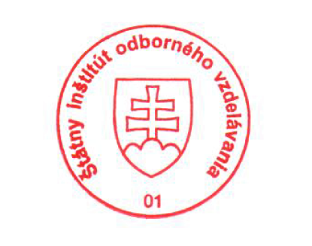
State Vocational Education Institute
Bellova 54/a,
837 63 Bratislava
europass@siov.sk
www.europass.sk

