1. Name of the Certificate ¹
Field of study 7667 N care for seniors in social services institutions (post-secondary education qualification)
2. Translated title of the Certificate ²
Študijný odbor 7667 N starostlivosť o seniorov sociálnych službách (pomaturitné kvalifikačné štúdium) (sk)
3. Profile of skills and competences
The holder of the certificate is able to:
- to adapt to changing living and working conditions, to work in a team and to take responsibility for assigned tasks,
- to work with information, to use information and communication technologies and equipment,
- to apply the principles of financial literacy, consumer protection and to understand business and the world of work,
- to act environmentally with regard to a sustainable development strategy,
- to apply basic legal rules, the principles of occupational health and safety and environmental protection,
- to communicate with people sensitively and tactfully,
- to provide basic first aid in response to accidents, small injuries and life-threatening conditions,
- to provide nursing care for the client independently, including adherence to the treatment regime at home and in institutions, in the scope determined by applicable regulations of the Ministry of Labour, Social Affairs and Family of the Slovak Republic,
- to apply nursing methods and procedures according to the principles of professional nursing,
- to create appropriate conditions to the client to perform self-care, including adherence to the treatment regime, housekeeping activities and basic social activities,
- to activate clients in the social services institutions and at home to perform musical, art, dramatic, sport, physical and professional activities,
- to prepare, perform and update individual nursing plan for the clients at home and in social services institutions,
- to process nursing documentation in terms of its content correctly,
- to collaborate with relatives of the client, with professionals from educational, advisory, health and social institutions,
- to apply knowledge of mental hygiene, methods and techniques of self-knowledge, self-regulation, self-discipline to handle stress and occupational hazards,
- to exercise and protect human rights.
4. Range of occupations accessible to the holder of the certificate ³
Graduates find work in professions and job titles in nursing and social care. Examples of potential job titles include: caregiver in social service institution, caregiver in household.

5. Official basis of the certificate
Body awarding the certificate | Authority providing accreditation / recognition of the certificate
Ministry of Education, Science, Research and Sport of the Slovak Republic
Stromová 1
813 30 Bratislava
Phone: +421 2/59 374 111
www.minedu.sk
Level of the certificate (national or European) ¹  Full secondary vocational education  SKQF/EQF 4  ISCED 454 | Grading scale / Pass requirements  1 – excellent  2 – praiseworthy  3 – good  4 – sufficient  5 – insufficient
Access to next level of education / training ¹  Higher vocational education, ISCED 554  University, 1st degree, ISCED 655, 645, 665  University, 2nd degree, ISCED 766 | International agreements on recognition of qualifications¹
Legal basis
Act No. 245/2008 Coll. on Education and Training (Education Act) and on amendment of certain acts; Act No. 61/2015 Coll. on Vocational Education and Training and on amendment of certain acts; Decree of the Ministry of Education of the Slovak Republic no. 318/2008 Coll. on the completion of studies at secondary schools, as amended.
6. Officially recognised ways of acquiring the certificate
Successful completion of the four-year training program in the given field of study by passing the school leaving examination.
7. Additional information
After successful completion of the training program in the given field of study the graduates receive a certificate confirming their passing of the school leaving examination.
Entry requirements ¹
- complete secondary general education, ISCED 344
- complete secondary vocational education, ISCED 354
- fulfilment of prerequisites in the admission procedure
More information (including a description of the national qualifications system)
Ministry of Education, Science, Research and Sport of the Slovak Republic, Study and Training Group
https://www.minedu.sk/18673-sk/studijne-a-ucebne-odbory-sauo/
National Europass Centre
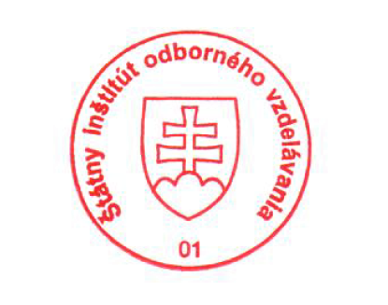
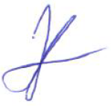
State Vocational Education Institute
Bellova 54/a,
837 63 Bratislava
europass@siov.sk
www.europass.sk

