1. Name of the Certificate ¹
Field of study 7662 M leisure activity leader
2. Translated title of the Certificate ²
Študijný odbor 7662 M animátor voľného času (sk)
3. Profile of skills and competences
The holder of the certificate is able to:
- to communicate correctly in the official language, both verbally and in writing,
- to communicate using one world language at least at the B1 level per the Common European Reference Framework,
- to adapt to changing living and working conditions, to work in a team and to take responsibility for assigned tasks,
- to work with information, to use information and communication technologies and equipment,
- to apply the principles of financial literacy,
- to act environmentally with regard to a sustainable development strategy,
- to apply basic legal rules, the principles of occupational health and safety and environmental protection,
- to provide basic first aid in response to accidents, small injuries and life-threatening conditions,
- to communicate with people sensitively and tactfully,
- to explain specifics of educational activity and integration of people with special educational needs,
- to design, organize and carry out leisure activities in individual leisure activity areas for children/students/clients and various age categories,
- to design program, organisational, material and staffing arrangement of a tourist activity,
- to apply basic pedagogical and psychological rules, precepts and principles while solving professional problems in practical activities,
- to plan, organize and manage leisure activities in a municipality, in state and commercial institutions and organisations providing leisure activities,
- to design and present project for the given or chosen topic in the area of leisure time activities,
- to prepare financial, material and staffing arrangement of various leisure activity programs,
- to apply arts, music and sport to leisure time activities,
- to exercise and protect human rights.
4. Range of occupations accessible to the holder of the certificate ³
Graduates find work in professions and job titles in the field of education outside school hours, in leisure activity, in educational, cultural institutions and tourist accommodation establishments.
Examples of potential job titles include educator in a leisure time centre, leisure activity leader.

5. Official basis of the certificate
Body awarding the certificate | Authority providing accreditation / recognition of the certificate
Ministry of Education, Science, Research and Sport of the Slovak Republic
Stromová 1
813 30 Bratislava
Phone: +421 2/59 374 111
www.minedu.sk
Level of the certificate (national or European) ¹  Full secondary vocational education  SKQF/EQF 4  ISCED 354 | Grading scale / Pass requirements  1 – excellent  2 – praiseworthy  3 – good  4 – sufficient  5 – insufficient
Access to next level of education / training ¹  Higher vocational education, ISCED 554  University, 1st degree, ISCED 655, 645, 665  University, 2nd degree, ISCED 766 | International agreements on recognition of qualifications¹
Legal basis
Act No. 245/2008 Coll. on Education and Training (Education Act) and on amendment of certain acts; Act No. 61/2015 Coll. on Vocational Education and Training and on amendment of certain acts; Decree of the Ministry of Education of the Slovak Republic no. 318/2008 Coll. on the completion of studies at secondary schools, as amended.
6. Officially recognised ways of acquiring the certificate
Successful completion of the four-year training program in the given field of study by passing the school leaving examination.
7. Additional information
After successful completion of the training program in the given field of study the graduates receive a certificate confirming their passing of the school leaving examination.
Entry requirements ¹
- lower secondary education ISCED 244
- fulfilment of prerequisites in the admission procedure
More information (including a description of the national qualifications system)
Ministry of Education, Science, Research and Sport of the Slovak Republic, Study and Training Group
https://www.minedu.sk/18673-sk/studijne-a-ucebne-odbory-sauo/
National Europass Centre
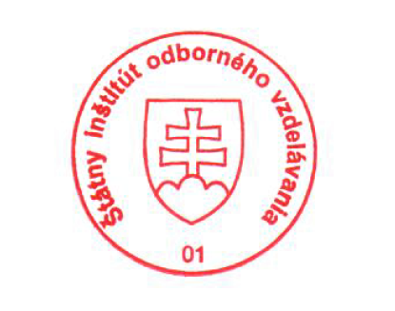
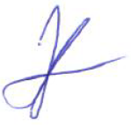
State Vocational Education Institute
Bellova 54/a,
837 63 Bratislava
europass@siov.sk
www.europass.sk

