1. Name of the Certificate ¹
Field of study 7646 M educational care activity
2. Translated title of the Certificate ²
Študijný odbor 7646 M vychovávateľsko-opatrovateľská činnosť (sk)
3. Profile of skills and competences
The holder of the certificate is able to:
- to communicate correctly in the official language, both verbally and in writing,
- to communicate using one world language at least at the B1 level per the Common European Reference Framework,
- to adapt to changing living and working conditions, to work in a team and to take responsibility for assigned tasks,
- to work with information, to use information and communication technologies and equipment,
- to apply the principles of financial literacy,
- to act environmentally with regard to a sustainable development strategy,
- to apply basic legal rules, the principles of occupational health and safety and environmental protection,
- to provide basic first aid in response to accidents, small injuries and life-threatening conditions,
- to apply knowledge from pedagogy and psychology into practice,
- to plan and carry out educational work in school educational institution under the responsibility of experienced pedagogue from practice,
- to solve problems of educational work in school educational institutions and in social service institutions,
- to handle integration of socially disadvantaged or disabled children/students/clients,
- to apply content, methods, forms, means of music education, arts, physical education, work education, aesthetic education, prosocial education, ethical education, intellectual education, environmental education in the subject areas of the school educational institution’s educational programme,
- to develop effective means of learning of children, to develop autonomy of children in preparation for the school courses in the school club,
- to select and use forms and methods aimed at carrying out leisure activities in school educational institutions,
- to provide nursing care for the client independently in the scope determined by applicable regulations of the Ministry of Labour, Social Affairs and Family of the Slovak Republic,
- to prepare and carry out nursing service plan in the household of a citizen and individual plan of nursing service in social service institutions,
- to solve problems of leisure activities of clients in social service institutions,
- to cooperate with specialists from educational, advisory, health and social institutions,
- to exercise and protect children's and client’s rights.

4. Range of occupations accessible to the holder of the certificate ³
Graduates find work in professions and job titles in education outside school hours, in nursing and social care.
Examples of potential job titles include educator in school educational institution, educator
in social assistance institutions, caregiver in household, caregiver in social services institutions.

5. Official basis of the certificate
Body awarding the certificate | Authority providing accreditation / recognition of the certificate
Ministry of Education, Science, Research and Sport of the Slovak Republic
Stromová 1
813 30 Bratislava
Phone: +421 2/59 374 111
www.minedu.sk
Level of the certificate (national or European) ¹  Full secondary vocational education  SKQF/EQF 4  ISCED 354 | Grading scale / Pass requirements  1 – excellent  2 – praiseworthy  3 – good  4 – sufficient  5 – insufficient
Access to next level of education / training ¹  Higher vocational education, ISCED 554  University, 1st degree, ISCED 655, 645, 665  University, 2nd degree, ISCED 766 | International agreements on recognition of qualifications¹
Legal basis
Act No. 245/2008 Coll. on Education and Training (Education Act) and on amendment of certain acts; Act No. 61/2015 Coll. on Vocational Education and Training and on amendment of certain acts; Decree of the Ministry of Education of the Slovak Republic no. 318/2008 Coll. on the completion of studies at secondary schools, as amended.
6. Officially recognised ways of acquiring the certificate
Successful completion of the four-year training program in the given field of study by passing the school leaving examination.
7. Additional information
After successful completion of the training program in the given field of study the graduates receive a certificate confirming their passing of the school leaving examination.
Entry requirements ¹
- lower secondary education ISCED 244
- fulfilment of prerequisites in the admission procedure
More information (including a description of the national qualifications system)
Ministry of Education, Science, Research and Sport of the Slovak Republic, Study and Training Group
https://www.minedu.sk/18673-sk/studijne-a-ucebne-odbory-sauo/
National Europass Centre
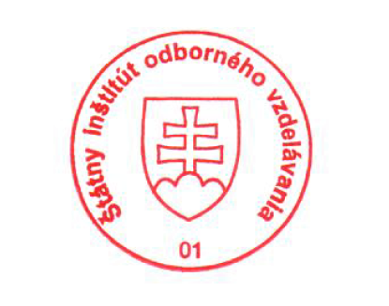
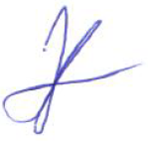
State Vocational Education Institute
Bellova 54/a,
837 63 Bratislava
europass@siov.sk
www.europass.sk

