1. Name of the Certificate ¹
Field of study 7518 Q Special pedagogy (post-secondary specialization qualification)
2. Translated title of the Certificate ²
Študijný odbor 7518 Q špeciálna pedagogika (pomaturitné špecializačné štúdium) (sk)
3. Profile of skills and competences
The holder of the certificate is able to:
- to communicate using at least one world language at the B1 level per the Common European Reference Framework, to apply vocabulary in the scope of the determined specialized topics,
- to work independently and creatively,
- to plan, organize, carry out and evaluate particular work procedures,
- to use information and communication technologies,
- to provide first aid in response to accidents, small injuries and life-threatening conditions,
- to plan, organize, carry out and evaluate educational activities of children/students with special educational needs,
- to apply content, methods, forms, means of educational work of children/students with special educational needs taking into consideration the specificities and limitations related to their disability,
- to apply principles and mechanisms of organizing integrated an inclusive education,
- to help integrate a child/student with special educational needs with the community and promote his/her acceptance in peer group,
- to apply special pedagogy diagnosis,
- to analyse and evaluate behaviour of a child/student,
- to apply special therapies,
- to create environment of acceptance and trust,
- to work with personal data of students and families discreetly and reliably,
- to cooperate with specialists from educational, advisory, health and social institutions and with parents,
- to apply methods of handling difficult life situations, occupational hazards and mental hygiene principles,
- to think independently and solve conflicts actively,
- to exercise human rights, basic professional legal standards and ethical principles.
4. Range of occupations accessible to the holder of the certificate ³
Graduates find work in professions and job titles in the field of education of children and students with special educational needs.
Examples of potential job titles include: Educator at schools and educational institutions for children and students with special educational needs.

5. Official basis of the certificate
Body awarding the certificate | Authority providing accreditation / recognition of the certificate
Ministry of Education, Science, Research and Sport of the Slovak Republic
Stromová 1
813 30 Bratislava
Phone: +421 2/59 374 111
www.minedu.sk
Level of the certificate (national or European) ¹  Higher vocational education  SKQF/EQF 5  ISCED 554 | Grading scale / Pass requirements  1 – excellent  2 – praiseworthy  3 – good  4 – sufficient  5 – insufficient
Access to next level of education / training ¹  University, 1st degree, ISCED 655, 645, 665  University, 2nd degree, ISCED 766 | International agreements on recognition of qualifications¹
Legal basis
Act No. 245/2008 Coll. on Education and Training (Education Act) and on amendment of certain acts; Act No. 61/2015 Coll. on Vocational Education and Training and on amendment of certain acts; Decree of the Ministry of Education of the Slovak Republic no. 318/2008 Coll. on the completion of studies at secondary schools, as amended.
6. Officially recognised ways of acquiring the certificate
Successful completion of the four-year training program in the given field of study by passing the school leaving examination.
7. Additional information
After successful completion of the training program in the given field of study the graduates receive a certificate confirming their passing of the school leaving examination.
Entry requirements ¹
- full secondary vocational education in the field of study of the study group 76 Teaching ISCED 354
- fulfilment of prerequisites in the admission procedure
More information (including a description of the national qualifications system)
Ministry of Education, Science, Research and Sport of the Slovak Republic, Study and Training Group
https://www.minedu.sk/18673-sk/studijne-a-ucebne-odbory-sauo/
National Europass Centre
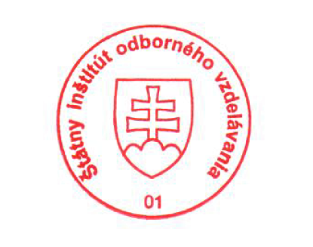
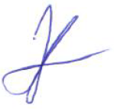
State Vocational Education Institute
Bellova 54/a,
837 63 Bratislava
europass@siov.sk
www.europass.sk

