1. Title of the certificate ¹
Field of Study 5370 M Hair Wellness Worker – Massage Services
2 . Translated title of the certificate ²
Študijný odbor 5370 M Wellness pracovník – Masérske služby (sk)
3. Profile of skills and competences
The holder of the certificate is able to:
- to apply epidemiological and hygiene measures,
- to apply the principles of health and safety at wellness establishments, water facilities and relaxation centres,
- to prepare the job site for massage,
- to conduct regular disinfection of instruments, aids and spaces following an approved plan,
- to provide first aid in the event of sudden health problems and injuries,
- to diagnose conditions in persons receiving massage and to identify muscle strain,
- to select and apply suitable massage means,
- to provide information during a massage,
- to apply the basics of tactile massage (friction, rubbing, kneading, hammering, shaking) and their variations in a coherent manner
- to deliver relaxation and recovery during massage of the head, face, neck, back, chest, stomach, upper limbs, lower limbs and sciatic muscles,
- to provide information to clients on proper use and the sequence of individual phases of using a sauna,
- to provide information on further options for rest and relaxation,
- to conduct sauna rituals as assigned (ice rituals, summer sauna rituals, relaxation rituals, fairy tale rituals for children, etc.),
- to conduct administrative work related to the performance of massage services and use of a sauna in wellness establishments,
- to conduct administrative work related to the operation of wellness establishments, water facilities and relaxation centres in accordance with principles for the protection of client personal data,
- to conduct cleaning and disinfection of sauna spaces - the sauna box, cooling-down space, foot bath, steam bath, etc.,
- to apply new knowledge to improve and enhance wellness services.
4. Range of occupations accessible to the holder of the certificate ³
Graduates find work in wellness establishments, in relaxation centres, in recreational facilities and other facilities designed for relaxation and recovery. They may conduct business activities after fulfilling the conditions of the Trade Licensing Act.

5. Official basis of the certificate
Body awarding the certificate | Authority providing accreditation / recognition of the certificate
Ministry of Education, Science, Research and Sport of the Slovak Republic
Stromová 1
813 30 Bratislava
Phone: +421 2/59 374 111
www.minedu.sk
Level of the certificate (national or European) ¹ | Grading scale / Pass requirement
SKKR/EKR: 4 | Pass  Fail
Access to next level of education / training ¹ | International agreements on recognition of qualifications ¹
Legal basis
Act No. 568/2009 Coll. on Lifelong Education and on amendment of certain acts, as amended and Decree No. 97/2010 Coll. as amended
6. Officially recognized ways of acquiring the certificate
Completion of an accredited training program in the scope of 280 hours.
Demonstration of professional experience

7. Additional information
Entry requirements ¹
More information (including a description of the national qualifications system)
More information is provided at www.minedu.sk, in the section of Lifelong Education, Further Education Information System, Testing to verify professional qualifications http://isdv.iedu.sk/Eligibility.aspx and on the website of the relevant holder of certification to verify professional qualifications.

National Europass Centre
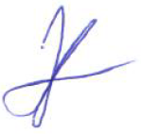
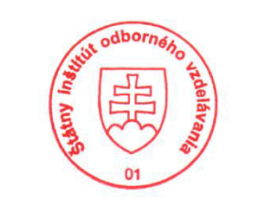
State Vocational Education Institute
Bellova 54/a,
837 63 Bratislava
europass@siov.sk
www.europass.sk

