1. Title of the certificate ¹
Field of Study 6446 K Cosmetologist
2 . Translated title of the certificate ²
Študijný odbor 6446 K Kozmetik (sk)
3. Profile of skills and competences
The holder of the certificate is able to:
- apply the principles of occupational health and safety in accordance with hygiene regulations applicable to cosmetic services,
- follow all operating rules, principles of disinfection, pest control, sterilization and its types,
- assess current skin quality,
- use diagnostics to define a skin type,
- select a work procedure based on skin condition and skin type,
- apply peels, superficial and deep skin cleaning,
- apply suitable care products,
- perform work with cosmetic devices (vaporizer, ozonizer, biostimulation laser, biotropic lamp, depilatory device)
- choose and ensure the application of appropriate masks, skin creams in within treatment steps,
- give face, neck, and décolletage massage,
- trim and dye eyebrows, eyelashes and to apply permanent eyelashes,
- perform depilatory procedures on the upper and lower limbs, armpits, bikini line, and remove upper lip hair,
- apply make-up based on all technological procedures with a focus on day make-up, evening make-up, wedding make-up, fashion make-up,
- apply make-up artist tricks, to apply face, eye, mouth and nose correction,
- apply makeup techniques, concealer, eye make-up, mouth make-up, powder
- provide hand care,
- provide aesthetic skin treatment as part of overall care for personal harmony.

4. Range of occupations accessible to the holder of the certificate ³
Graduates find work in cosmetic salons, in hotels, in treatment centres, in cosmetics stores and in perfume stores. They also find work in the cosmetics industry. They may conduct business activities after fulfilling the conditions of the Trade Licensing Act.

5. Official basis of the certificate
Body awarding the certificate | Authority providing accreditation / recognition of the certificate
Ministry of Education, Science, Research and Sport of the Slovak Republic
Stromová 1
813 30 Bratislava
Phone: +421 2/59 374 111
www.minedu.sk
Level of the certificate (national or European) ¹ | Grading scale / Pass requirement
SKKR/EKR: 4 | Pass  Fail
Access to next level of education / training ¹ | International agreements on recognition of qualifications ¹
Legal basis
Act No. 568/2009 Coll. on Lifelong Education and on amendment of certain acts, as amended and Decree No. 97/2010 Coll. as amended
6. Officially recognized ways of acquiring the certificate
Completion of an accredited training program in the scope of 450 hours.
Demonstration of professional experience

7. Additional information
Entry requirements ¹
More information (including a description of the national qualifications system)
More information is provided at www.minedu.sk, in the section of Lifelong Education, Further Education Information System, Testing to verify professional qualifications http://isdv.iedu.sk/Eligibility.aspx and on the website of the relevant holder of certification to verify professional qualifications.

National Europass Centre
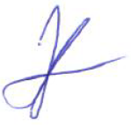
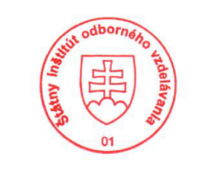
State Vocational Education Institute
Bellova 54/a,
837 63 Bratislava
europass@siov.sk
www.europass.sk

