1. Name of the Certificate ¹
Field of study 3454 L polygraphic industry
2. Translated title of the Certificate ²
Polygrafický priemysel (sk)
3. Profile of skills and competences
The holder of the certificate is able to:
- assess templates for image reproduction, manuscript and the final print,
- implement the artistic requirements of the graphic, assess the graphic level of printed media or prepare them himself,
- know his way around with the selection, determination and assessment of the quality of polygraphic materials,
- determine the technical parameters of production and the technological procedures according to the specific production conditions of the given printed media,
- perform routine calculations during reproduction, typesetting, printing and finishing of printed media,
- process and maintain routine operational documentation related to production management in the printing enterprise,
- master electronically controlled systems used in polygraphic applications,
- use basic knowledge of economics and production management,
- perform input, inter-operational and output controls of raw materials, production materials, semi-finished products and products in polygraphic production,
- observe the principles of safety at work and occupational hygiene,
- apply the principles of environmental protection.
4. Range of occupations accessible to the holder of the certificate ³
The graduate can find employment in professions in the field of producing printed media by all available printing technologies. The graduate can also be employed in advertising agencies and graphic studios for defining the most suitable printing techniques for the given type of graphic product and in professional assessment of print quality. Furthermore the graduate can be employed in a publishing house as a production manager.
Examples of possible job positions: polygraph, polygraph technician.

5. Official basis of the certificate
Body awarding the certificate | Authority providing accreditation / recognition of the certificate
Ministry of Education, Science, Research and Sport of the Slovak Republic
Stromová 1
813 30 Bratislava
Phone: +421 2/59 374 111
www.minedu.sk
Level of the certificate (national or European) ¹  Full secondary vocational education  SKQF/EQF: 4  ISCED 354 | Grading scale / Pass requirements  1 – excellent  2 – praiseworthy  3 – good  4 – sufficient  5 – insufficient
Access to next level of education / training ¹  University, 1st degree, ISCED 655, 645, 665  University, 2nd degree, ISCED 766, 767 | International agreements on the recognition of qualifications ¹
Legal basis
Act No. 245/2008 Coll. on Education and Training (Education Act) and on amendment of certain acts; Act No. 61/2015 Coll. on Vocational Education and Training and on amendment of certain acts; Decree of the Ministry of Education of the Slovak Republic no. 318/2008 Coll. on the completion of studies at secondary schools, as amended.
6. Officially recognised ways of acquiring the certificate
Successful completion of the four year training program in the given field of study by passing the school leaving examination.
7. Additional information
After successful completion of the training program in the given field of study the graduates receive a certificate confirming their passing of the school leaving examination.
Entry requirements ¹
- lower secondary education, ISCED 244
- fulfilment of prerequisites in the admission procedure
More information (including a description of the national qualifications system)
Ministry of Education, Science, Research and Sport of the Slovak Republic, Study and Training Group
https://www.minedu.sk/18673-sk/studijne-a-ucebne-odbory-sauo/
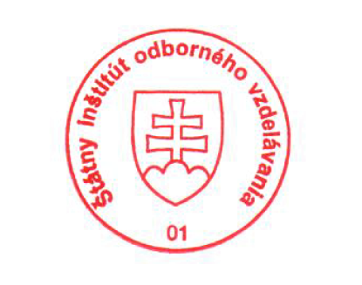 National Europass Centre
State Vocational Education Institute
Bellova 54/a,
837 63 Bratislava
europass@siov.sk
www.europass.sk

