1. Name of the Certificate ¹
Field of study 3447 K digital media graphic designer
2. Translated title of the Certificate ²
Grafik digitálnych médií (sk)
3. Profile of skills and competences
The holder of the certificate is able to:
- prepare a work plan and determine the work procedure for creating digital media based on the parameters of the assigned order,
- select and prepare the necessary tools, machines and devices, materials and aids necessary for a specific technological process and use them efficiently,
- apply knowledge of computer science, applied computer technology and graphic design during the graphic design of the digital media,
- master the procedures of graphic preparations of materials and have a grasp of procedures for digital media production,
- use applications for processing words, images, sequences and programs for publishing texts and images,
- use data storage, cloud systems available at the workplace,
- create static photography, photographs of objects via studio photography, photography of architecture, journalistic photographs and macro photographs,
- create prototypes of the appearance and functionality of the digital application, responsive adaptive graphic layout of websites in a unified graphic style for individual parts of the websites,
- create a dynamic comprehensive website using the latest technologies in accordance with internationally accepted standards,
- apply SEO retrieval of backlinks for published digital media, effectively promote digital media using online marketing,
- design and process the complete graphic identity of a company,
- create an original vector image,
- work with digital cameras, create and edit video sequences and export data to appropriate formats,
- create an e-publication with navigation,
- observe the principles of safety at work and occupational hygiene,
- apply the principles of environmental protection.
4. Range of occupations accessible to the holder of the certificate ³
The graduate can find employment in professions in the field of producing digital media published especially on the internet. The graduate can also find employment in advertising agencies and graphic studios in the creation of multimedia products, web design, etc.
Examples of possible job positions: digital media graphic designer, front end digital media developer, graphic for digital media, graphic designer of web applications, graphic and animator for 2D/3D graphic, online graphic designer, digital graphic designer.

5. Official basis of the certificate
Body awarding the certificate | Authority providing accreditation / recognition of the certificate
Ministry of Education, Science, Research and Sport of the Slovak Republic
Stromová 1
813 30 Bratislava
Phone: +421 2/59 374 111
www.minedu.sk
Level of the certificate (national or European) ¹  Full secondary vocational education  SKQF/EQF: 4  ISCED 354 | Grading scale / Pass requirements  1 – excellent  2 – praiseworthy  3 – good  4 – sufficient  5 – insufficient
Access to education leading to higher levels of education ¹  University, 1st degree, ISCED 655, 645, 665  University, 2nd degree, ISCED 766, 767 | International agreements on the recognition of qualifications ¹
Legal basis
Act No. 245/2008 Coll. on Education and Training (Education Act) and on amendment of certain acts; Act No. 61/2015 Coll. on Vocational Education and Training and on amendment of certain acts; Decree of the Ministry of Education of the Slovak Republic no. 318/2008 Coll. on the completion of studies at secondary schools, as amended.
6. Officially recognised ways of acquiring the certificate
Successful completion of the four-year training program in the given field of study by passing the school leaving examination.
7. Additional information
After successful completion of the training program in the given field of study the graduates receive a certificate confirming their passing of the school leaving examination and a vocational certificate.
Entry requirements ¹
- lower secondary education, ISCED 244
- fulfilment of prerequisites in the admission procedure
More information (including a description of the national qualifications system)
Ministry of Education, Science, Research and Sport of the Slovak Republic, Study and Training Group
https://www.minedu.sk/18673-sk/studijne-a-ucebne-odbory-sauo/
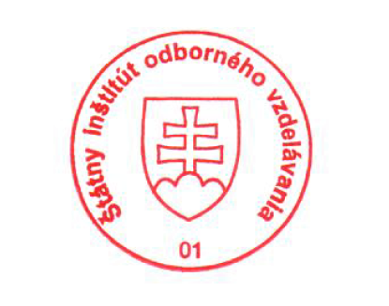 National Europass Centre
State Vocational Education Institute
Bellova 54/a,
837 63 Bratislava
europass@siov.sk
www.europass.sk

