1. Name of certificate ¹
Field of study 3434 K packaking operator
2. Translation of the name of the certificate ²
Operátor obalových materiálov (sk)
3. Profile of skills and competences
The holder of the certificate is able to:
- prepare a packaging production machine,
- prepare materials, agents and aids in packaging production,
- operate machines and equipment for the production paper, cardboard, pasteboard and foils,
- prepare materials related to the production of packaging from paper, cardboard, pasteboard and foils,
- choose technological conditions and parameters for the processing of packaging,
- comply with the prescribed technological procedures in the production of packaging,
- check the operability of the machines and equipment in packaging production,
- record technical data and work outcome during packaging production,
- comply with technical standards in the production of packaging,
- regulate the process of packaging production and eliminate basic errors arising in the process of packaging production,
- check the quality of products in packaging production,
- use professional terminology for the production of packaging,
- decide on the use of materials for individual types of packaging,
- check the operability of the packaging production machine,
- check, operate, maintain and clean production equipment,
- perform input, inter-operational and output controls of raw materials, production materials, semi-finished products and products in packaging production,
- observe the principles of safety at work and occupational hygiene,
- apply the principles of environmental protection.
4. Range of occupations accessible to the holder of the certificate ³
The graduate can find employment in the field of production of packaging and packaging materials by all available production techniques. The graduate can also be employed in advertising agencies and graphic studios for defining the most suitable production and printing techniques for the given type of packaging and in professional assessment of the packaging quality.
Examples of possible job positions: packaging materials operator, packaging production operator, paper products operator, foreman for packaging production, packaging technician, packer.

5. Official basis of the certificate
Body awarding the certificate | Authority providing accreditation / recognition of the certificate
Ministry of Education, Science, Research and Sport of the Slovak Republic
Stromová 1
813 30 Bratislava
Phone: +421 2/59 374 111
www.minedu.sk
Level of the certificate (national or European) ¹  Full secondary vocational education  SKQF/EQF: 4  ISCED 354 | Grading scale / Pass requirements  1 – excellent  2 – praiseworthy  3 – good  4 – sufficient  5 – insufficient
Access to next level of education / training ¹  University, 1st degree, ISCED 655, 645, 665  University, 2nd degree, ISCED 766, 767 | International agreements on the recognition of qualifications ¹
Legal basis
Act No. 245/2008 Coll. on Education and Training (Education Act) and on amendment of certain acts; Act No. 61/2015 Coll. on Vocational Education and Training and on amendment of certain acts; Decree of the Ministry of Education of the Slovak Republic no. 318/2008 Coll. on the completion of studies at secondary schools, as amended.
6. Officially recognised ways of acquiring the certificate
Successful completion of the four-year training program in the given field of study by passing the school leaving examination.
7. Additional information
After successful completion of the training program in the given field of study the graduates receive a certificate confirming their passing of the school leaving examination and a vocational certificate.
Entry requirements ¹
- lower secondary education, ISCED 244
- fulfilment of prerequisites in the admission procedure
More information (including a description of the national qualifications system)
Ministry of Education, Science, Research and Sport of the Slovak Republic, Study and Training Group
https://www.minedu.sk/18673-sk/studijne-a-ucebne-odbory-sauo/
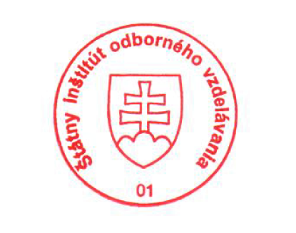 National Europass Centre
State Vocational Education Institute
Bellova 54/a,
837 63 Bratislava
europass@siov.sk
www.europass.sk

